

Department of Computer Science COMP4200-Introduction to Graduation Project
Project Proposal 2025/2026 Section – 2

Title of Project :

Birzeit University Insurance System

Group Members with IDs :

Jadallah Baragitha | 1210395
Mousa Shuaib | 1210143
Osaid Hamayel | 1211958

Supervisor :

Dr. Samer Zein

Section – B

Title of Project: Birzeit University Insurance System

Project No: 1

Supervisor: Dr. Samer Zein

Key Areas: Healthcare Data Management ,Software Development and integration, Claims Processing, Data Privacy & Compliance, Software Integration, User Interfaces & Experience, Customer Support, Reporting.

Section – C

Student Signature: Date Submitted:
First Supervisor Name:

First Supervisor Signature: Date Approved: / /

Acknowledgments

We would like to express our sincere gratitude to our supervisor, Dr. Samer Zein, for his support and guidance throughout the design of this project. His expertise and insight were valuable to our learning journey and the successful completion of this phase of the report.

We, Jadallah Baraghitha, Mousa Shuaib, and Osaid Hamayel, worked together as a team to complete this phase of the project design. We are grateful for the opportunity to grow as a team, learn from each other, and collaborate in the coming semester to transform the insurance system from a dream to a reality.

Table of Contents

Abstract 6
Ch 1. Introduction 8
  - Overview 8
  - Goals & Objectives 10
    - Aims 10
    - Objectives 10
    - Motivation 11
    - Method 11
    - Tools and Technology 12
1.3 Report Structure 16
Ch 2. Literature Review 17
  - Background 17
  - Overview of the technical area 19
  - Similar Apps 21
Ch 3. System Design and Analysis 23
  - Software Description 23
    - System Objective & Main features 23
    - System Requirement 25
    - System Non-functional aspects 28
  - Functional Decomposition 30
    - System Actors Roles 30
    - Use Cases Summarization 31
  - System Modeling 32
3.3.1 Class Diagram 33
3.3.2 Sequence Diagram 34
3.3.3 Activity Diagram 38
3.4 ERD Diagram 41
3.5 Sub-System 42
3.6 System environments 44
  - System Architecture 47
    - Software Architecture 47
    - GUI Design 51
Chapter 4: Conclusion and Future works: 66
4.1Review of the project 66
4.2Future works 67
- References 70
- Abbreviations 71
- Turnitin 72

Abstract

With over 15,000 students and more than 1,000 faculty and staff, Birzeit University requires an efficient and reliable system to manage its growing healthcare and insurance needs. A well-structured insurance system is essential to ensure timely access to medical services, accurate claims processing, and effective communication between all stakeholders. The Birzeit University Insurance System shall be a comprehensive digital platform designed to simplify and enhance the management of health insurance services for the university community. The system shall provide a user-friendly interface and shall integrate with the latest technologies to enable seamless enrollment, claims processing, and medical records management. By automating key processes—such as claims submission, document handling, and emergency requests—the system shall reduce administrative workload and ensure faster, more efficient handling of insurance-related tasks. It shall offer strong data protection, comply with privacy regulations, and be accessible through both mobile and web platforms. Additionally, the system shall feature real-time notifications and personalized alerts for appointments, prescription availability, and claim status updates. Smart capabilities shall support rapid document updates and enable informed decision-making by insurance managers. Ultimately, this system shall serve as a secure, modern, and reliable solution that improves efficiency and transparency in managing healthcare services across the university.

List of Figures

Figure 1 Spring Boot 12
Figure 2 React Native 20
Figure 3 App Comparison Tabel 22
Figure 4 System Actors Roles 30
Figure 5 Use Case Diagram 31
Figure 6 Class Diagram 33
Figure 7 Registration Sequence Diagram 34
Figure 8 system Notification sequence diagram 36
Figure 9 EMRSQDIA Sequence Diagram 37
Figure 10 User Activity Diagram 38
Figure 11 Notification Activity Diagram 39
Figure 12 EMRSQDIA Activity Diagram 40
Figure 13 ERD Diagram 41
Figure 14 High Level Architecture 48
Figure 15 Deployment Diagram 49
Figure 16 Component Diagram 50
Figure 17 Registration web& mobile 51
Figure 18 Login web& mobile 52
Figure 19 Member Web& mobile 53
Figure 20 Doctor web& Mobile 54
Figure 21 Doctor Registration Web& Mobile 55
Figure 22 Doctor Report 1 56
Figure 23 Doctor Report 2 57
Figure 24 Pharamtics Registration 58
Figure 25 Lab Worker Registration 59
Figure 26 Pharamtics Enquiry 60
Figure 27 Lab Work Enquiry 61
Figure 28 Doctor Enquiry 62
Figure 29 Emergency Report 63
Figure 30 Medical Worker Report 64
Figure 3 Member Report 65

Chapter 1. Introduction

Overview

Health insurance plays a vital role in ensuring accessible, affordable, and timely healthcare services for all members of a university community. At Birzeit University—home to thousands of students, faculty, and staff—the demand for a streamlined and responsive insurance system has become increasingly critical. An effective insurance platform not only reduces administrative burden but also enhances the well-being and satisfaction of its users by facilitating seamless access to medical services and benefits.
The Birzeit University Insurance System shall be a comprehensive digital platform designed to simplify and improve the management of health insurance services for the university community, including professors, faculty, staff, and students. Although not yet in operation, the system shall be developed as a modern, secure, and user-friendly solution that leverages advanced technologies to support the university’s evolving healthcare needs.
The system shall streamline key processes such as registration, claims submission, policy tracking, and medical record management. With intuitive, role-based interfaces, users shall complete tasks efficiently and with minimal effort. The system shall be available via both web and mobile platforms, ensuring flexible access on or off campus.
One of the main goals of the system shall be the automation of routine tasks, including claims processing, document validation, and appointment scheduling. This shall reduce human error, speed up services, and provide greater transparency. The system shall also comply fully with privacy and data protection standards to secure sensitive health information.
In typical use, a university member shall be able to log in, review their insurance status, submit a claim, and track updates—all within a few steps. Real-time alerts for appointments, prescriptions, and claim progress shall enhance communication and provide a smooth, efficient experience.

Main Feature: Smart Claim Auto-Fill & One-Click Submission
Among the system's features, the Smart Autofill and One-Click Submission feature is one of its most innovative and user-friendly enhancements.
This feature allows users, especially faculty and staff, to submit insurance claims in seconds. When a user submits a new claim, the system automatically retrieves data from the most recent similar claim and uses it to pre-populate the new form. Fields such as the doctor's name, department, diagnosis, and clinic location are immediately filled in.

The user can then review the pre-populated information, make any necessary adjustments (such as updating the visit date or uploading a new receipt), and submit the claim with one click. This feature eliminates the need to re-enter duplicate information, reduces form complexity, and encourages more accurate and timely claims submission.

The Birzeit University Insurance System represents a significant advancement in university-wide healthcare management. Through intelligent automation, secure digital services, and a user-centered design approach, the system will set a new standard for insurance operations in academic institutions and positively transform the healthcare experience for the Birzeit University community.

Goals & Objectives

Aims

This project aims to develop a comprehensive, secure, and user-friendly health insurance platform for Birzeit University that simplifies communication, claims processing, and insurance policy management. The platform will leverage the latest web and mobile technologies to enhance the efficiency and accessibility of insurance-related services for faculty and staff. Real-time data updates will be integrated to ensure the accuracy and timeliness of insurance information, eliminating the need for traditional paper document management to streamline processes and enhance the speed of healthcare management. The project will also establish a seamless and efficient communication system between university stakeholders—including students, faculty, administration, physicians, medical laboratories, and pharmacists—and insurance providers. Furthermore, the project aims to reduce the administrative burden on insurance staff by automating processes and improving data management systems.

Objectives

- Ensure safe and efficient health insurance management for all university members:
This will be achieved by implementing secure, digital platforms for managing insurance data, ensuring both accessibility and privacy, and using automated tools to process insurance details quickly and accurately.
- Streamline the insurance claims process through automated systems and user-friendly interfaces:
Automation of claims submission and tracking will significantly reduce manual errors and processing time, improving efficiency and user satisfaction. The user interface will be designed to ensure ease of use for all stakeholders.
- Reduce administrative burden by automating routine tasks and managing policies more efficiently:
Routine tasks such as document management, claims tracking, and policy updates will be automated, allowing insurance personnel to focus on higher-value activities. This will result in faster processing times and reduced workloads.
- Protect the privacy and security of user data in accordance with privacy regulations:
The system will comply with strict data security standards and privacy regulations, incorporating encryption and secure access controls to ensure the confidentiality and integrity of sensitive health information.

Motivation

Birzeit University's health insurance system was developed to address challenges facing traditional insurance administration, such as inefficiencies, data inaccuracy, and difficulty accessing information. The current system relies on paper-based processes and manual interventions, leading to delays, errors, and frustration for users. Claims processing is slow, and the lack of a central platform makes it difficult for users to access up-to-date information about their coverage and claim status.
Additionally, communication between stakeholders, including students, faculty, insurance providers, and healthcare providers, is often inefficient, as important notifications, such as claims updates and appointment reminders, are not delivered in real-time. Relying on manual record-keeping also contributes to errors, undermining confidence in the system's accuracy.

This project aims to modernize healthcare services at the university and ensure data security and privacy. By leveraging modern technologies, the system will improve the speed and accuracy of claims processing, enhance communication, and allow users to easily access their insurance information. The new platform will provide centralized access, real-time updates, a more efficient process, and meet the evolving needs of the university community.

Method
The development of the Birzeit University Insurance System shall follow the traditional Waterfall software development model, which emphasizes a structured, sequential approach. This method was chosen to ensure thorough planning, clear documentation, and organized progress through each development phase—from requirements gathering and system design to implementation, testing, deployment, and maintenance.
The system shall be carefully designed to provide a comprehensive, secure, and user-friendly experience. It shall integrate both web and mobile technologies, allowing users to easily access their insurance information and track the status of their claims across multiple devices.
The back-end system architecture shall incorporate automated claims processing and document management, supported by secure data storage mechanisms to ensure privacy and full compliance with regulatory standards. The user interfaces shall be responsive and intuitive, offering a smooth and consistent experience on both desktop and mobile platforms. Additionally, real-time notifications and other smart features shall be implemented to enhance efficiency, support timely decision-making, and enable users and administrators to manage insurance services effectively.

Tools and Technology

- Backend: Spring Boot 

Spring Boot is a framework that simplifies Java web application development by automating configuration and reducing the need for manual setup. It is designed to create stand-alone, production ready applications with minimal code. Key features include fast bootstrapping,
auto-configuration, and embedded web servers. It supports easy integration with various tools, facilitates building RESTful APIs, and ensures scalability and strong security making it a reliable choice for backend development in systems like health insurance. [1]

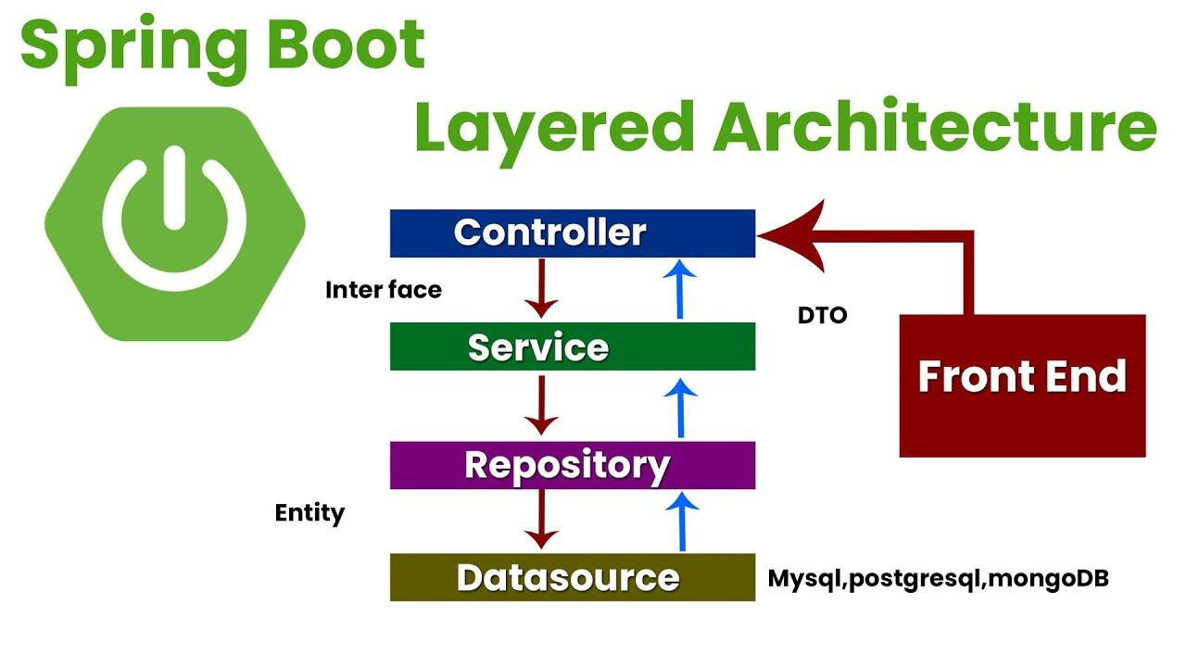
Figure 1: Spring Boot [2]

- Web: React 

React.js is a widely used JavaScript library for building user interfaces, particularly in dynamic and responsive web applications. It employs a component-based architecture, which simplifies the management of complex interfaces by breaking them down into smaller, reusable components. React utilizes a virtual DOM for efficient updates, enhancing performance by updating only the necessary components. It is also used for mobile app development with React Native and integrates seamlessly with npm (Node Package Manager) for managing third-party packages. [3]

- Mobile: React Native

- React Native is a powerful JavaScript framework used to build native mobile applications for both iOS
and Android platforms. It allows developers to create cross-platform apps that maintain a native look and feel by using JavaScript and JSX, an XML-like syntax. React Native bridges the gap between web development and mobile development by rendering UI components using native APIs, ensuring high performance and a seamless native experience. Popular companies like Facebook and Palantir have leveraged React Native for their production-ready mobile applications. With its support for both iOS and Android, React Native provides a unified approach to mobile app development while maintaining
platform-specific optimizations. [4]

- One of the key distinctions between React for the Web and React Native is the way they interact with platform-specific APIs. While React for the Web deals with standardized features that are consistent across different browsers, React Native applications must cater to the unique APIs of each platform, namely iOS and Android. This platform-specific consideration is crucial when developing mobile applications, as it ensures that the app interacts properly with the features and services of each operating system. React Native also simplifies the usage of mobile-specific APIs, such as location services, camera functionalities, and storage, allowing developers to integrate these features easily into their applications using the React Native bridge. This ensures a truly native experience for users on both platforms. [4]

- React Native is designed with flexibility in mind, allowing developers to customize components or add features when necessary. If an API is not exposed by default, developers can extend React Native to meet their needs. However, this customization can sometimes lead to platform-specific code, requiring developers to carefully manage and isolate components for optimal code reuse. As the framework continues to evolve, there is potential for React Native to support even more platforms in the future, including virtual reality (VR) headsets, further expanding its capabilities and reach. [4]

- When it comes to writing components, React Native differs significantly from React for the Web. In React Native, JSX is mandatory, and mobile components like <View> are used in place of traditional HTML elements like <div>. Styling in React Native is also handled differently from web development. Instead of using traditional CSS, developers use inline styles applied directly to components, which helps maintain the native performance and appearance of the application. Additionally, when designing applications for React Native, developers must consider the platform-specific design paradigms to ensure that the app feels intuitive and natural on both iOS and Android devices. This means thinking about how users naturally interact with their devices and ensuring that the mobile experience reflects those expectations. [4]
- Database: PostgreSQL 

PostgreSQL is an advanced open-source Object-Relational Database Management System (ORDBMS) that handles complex queries and large datasets. It supports ACID transactions, ensuring data integrity, and is ideal for managing structured data in applications like health insurance systems. As an open-source project, PostgreSQL allows users to modify the source code to suit their needs, making it a versatile and reliable choice for various database management tasks. [5]
- Cloud: AWS 

AWS (Amazon Web Services) is a scalable cloud computing platform offering services like EC2 for computing, S3 for storage, RDS for databases, and Lambda for serverless computing.
It provides a flexible, cost-effective, and reliable infrastructure ideal for building and scaling systems, such as health insurance applications. AWS ensures high availability and performance while managing costs efficiently. [6]
- Testing API : 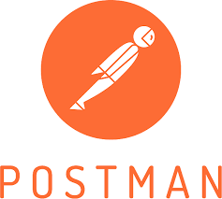

Postman is an API testing tool that enables developers to send requests to servers, inspect
responses, and verify backend functionality. It supports HTTP methods like GET, POST, PUT, and DELETE, and allows for dynamic parameters and headers. Postman simplifies the process of automating API tests, integrating them into CI/CD pipelines, and monitoring API performance.
Its user-friendly interface and features, such as response analysis and test collections, make it an essential tool for ensuring API reliability and quality in software development. [7]

- Version Control: 

Git is a distributed version control system (DVCS) that helps developers track and manage changes in project files, allowing each developer to have a complete copy of the project's history. Git repositories store project files and their revision histories, enabling easy collaboration and independent work.

GitHub is a web-based platform that hosts Git repositories and offers collaboration tools like issues, pull requests, and code review features.

Common Git commands, such as git init, git add, git commit, git push, and git pull, allow developers to manage and update their code. GitHub enhances collaboration by offering a platform where developers can create branches, propose changes, and merge updates through the GitHub flow. [8]

- Figma Design: 

Figma is a cloud-based UX/UI design tool known for its real-time collaboration features, enabling multiple designers to work simultaneously on projects. It is accessible across various operating systems like Windows, Mac, Linux, and ChromeOS. Figma covers all aspects of design, from wireframing and prototyping to high-fidelity design and sharing, making it an all-in-one solution. Its version control and integration with design systems make it suitable for fast-paced environments. Additionally, Figma’s strong community and plugin ecosystem provide users with added resources and inspiration. [9]

Report Structure

This report is organized into seven main chapters as follows:
  - Chapter 1 provides an introduction to the project, highlighting the importance of health insurance at Birzeit University, the goals and objectives of the proposed system, the motivation behind its development, the tools and technologies to be used, and the methodology adopted.

  - Chapter 2 presents the literature review, including the background of health insurance systems and an overview of relevant technical areas and technologies.

  - Chapter 3 focuses on system design and analysis. It begins with a software description, including objectives, environments, and system requirements (functional and non-functional). It continues with the functional decomposition, use case modeling, and system modeling diagrams such as class, sequence, activity, and ERD diagrams. This chapter also covers subsystem identification and system architecture, including both software structure and UI design using Figma.

  - Chapter 4 concludes the report with a review of the project’s outcomes and suggests directions for future development and improvements.

  - Chapter 5 lists all references cited throughout the report.
  - Chapter 6 includes the bibliography of additional sources consulted during research.
  - Chapter 7 presents the Turnitin originality report as required for academic integrity.

Chapter 2: Literature Review

Background
Health insurance plays a critical role in ensuring individuals have access to healthcare services and financial protection. Over the years, health insurance systems have evolved to meet the changing needs of communities, providing coverage for medical costs and improving access to healthcare. Advances in technology have played a significant role in shaping how health insurance is administered, making it more efficient and accessible. [10]
In the past, health insurance processes were manual, requiring significant administrative efforts to manage claims, track policies, and communicate with healthcare providers. However, with advances in technology, health insurance systems have increasingly moved toward digital platforms that automate and simplify many of these processes. This shift has allowed for more efficient management and reduced the risk of human error. [11]
Despite these advancements, the health insurance sector still faces several challenges, including complex claims processing, lack of immediate access to insurance information, and difficulty integrating various healthcare providers. These issues have contributed to inefficiencies, user frustration, and low levels of trust in the system. In 2023, a report showed that 36% of patients expressed dissatisfaction with their health insurance providers, citing long claims processing times and difficulty accessing services as the main reasons [12]
Over the years, voting systems have evolved to address various challenges and improve the voting experience. Here's a brief overview of this evolution:

Traditional Health Insurance Systems:
  - Paper-based systems: Health insurance traditionally relied heavily on paper records, which were time-consuming to manage and prone to errors. This system often involved lengthy paperwork, delayed claims processing, and difficulty tracking policy details. [13]
  - Manual claims processing: Claims were manually reviewed, resulting in slow reimbursement times and an increased likelihood of human error. [13]

Web2.0 Health Insurance Systems:

With the development of the internet and Web 2.0 technologies, health insurance systems began incorporating digital platforms to manage claims and insurance policy information. These platforms offered several advantages, such as: [14]
- Increased access for users to check their insurance details online.
- Faster claims processing compared to traditional paper-based systems.
- However, Web 2.0 systems also faced significant issues:
- Security risks: Many platforms were centralized, and user data was stored on central servers, making them vulnerable to data breaches and hacking attempts.
- Lack of transparency: Users often had difficulty understanding how their claims were being processed or verifying the accuracy of their coverage.
Next-generation health insurance systems, such as Birzeit University's health insurance system, aim to address these shortcomings by integrating advanced technologies to create a more efficient, user-friendly, and secure platform for managing insurance services.

Overview of the technical area

Related Work

React Native
React Native is a powerful JavaScript framework used to build native mobile applications for both IOS and Android platforms. It allows developers to create cross-platform apps that maintain a native look and feel by using JavaScript and JSX, an XML-like syntax. React Native bridges the gap between web development and mobile development by rendering UI components using native APIs, ensuring high performance and a seamless native experience. Popular companies like Facebook and Palantir have leveraged React Native for their production-ready mobile applications. With its support for both iOS and Android, React Native provides a unified approach to mobile app development while maintaining platform-specific optimizations. [15]
One of the key distinctions between React for the Web and React Native is the way they interact with platform-specific APIs. While React for the Web deals with standardized features that are consistent across different browsers, React Native applications must cater to the unique APIs of each platform, namely iOS and Android. This platform-specific consideration is crucial when developing mobile applications, as it ensures that the app interacts properly with the features and services of each operating system. React Native also simplifies the usage of mobile-specific APIs, such as location services, camera functionalities, and storage, allowing developers to integrate these features easily into their applications using the React Native bridge. This ensures a truly native experience for users on both platforms. [15]
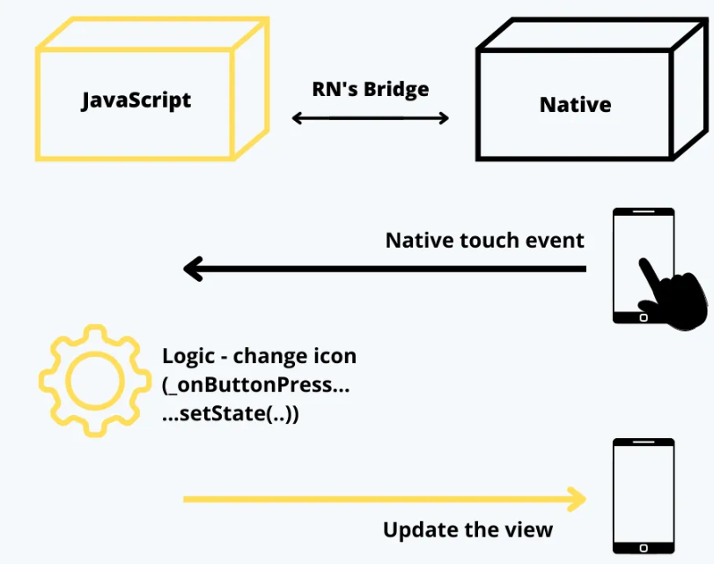
Figure 2 React Native [15].

Spring Boot
Spring Boot is an open source extension to the Spring framework that simplifies the creation of standalone, production-ready Java applications by enabling automatic configuration and embedded servers without the need for complex XML setup. Research has shown that Spring Boot significantly reduces development time—up to 40% in large enterprise environments—and reduces deployment issues by leveraging features such as automatic configuration, startup dependencies, and embedded web servers. This makes it ideal for quickly building microservices, scalable web applications, and modern backend systems with minimal out-of-the-box code and strong support for a modular, cloud-native architecture. [16]

PostgreSQL
PostgreSQL is an open source object-relational database management system (ORDBMS) that originated from the POSTGRES project at the University of California, Berkeley, in the 1980s and has since evolved over three decades into a robust, scalable, and standards-compliant platform. The system supports complex data types, full SQL compatibility, ACID transactions, and features such as multi-version concurrency control (MVCC), write-ahead logging, and native replication, making it ideal for analytical and transactional workloads. [17]

Similar Apps

In recent years, several health insurance apps have been developed to enhance access to healthcare and simplify insurance-related processes. A prominent example is myCigna, provided by global health services company Cigna. This app allows users to access their insurance ID cards, submit and track claims, search for healthcare providers, view their medical history, and estimate treatment costs. While highly effective for individual users managing personal healthcare plans, the app is designed for general use and does not support academic workflows, such as verifying student eligibility or handling university emergency claims.. [18]

The Sehaty platform, developed by the Saudi Ministry of Health, is another widely used platform.

Sehaty integrates national health insurance with digital health services, allowing users to book medical appointments, view test results, track vaccinations and medications, and access COVID-19 health data. Although Sehaty is fully integrated with the national health infrastructure and provides efficient medical services, it is not designed for local institutions such as universities and does not provide role-based interactive interfaces for administrators, students, and healthcare providers. [19]

In contrast, Birzeit University's health insurance system is specifically designed to meet the unique

needs of an academic environment. It provides role-based access for students, faculty, administrators,

and medical providers, facilitating communication and policy management across the institution. The system integrates with university platforms such as Ritaj for automatic eligibility verification and

includes dedicated modules for emergency claims, auto-filled smart claims forms, and real-time notifications. These features are rarely available in general health insurance applications, making Birzeit University's system a more specialized and effective solution for managing health insurance on campus.

App Comparison Table

Feature | myCigna | Sehaty | Birzeit University Insurance System
Insurance ID Card Access | Available | Not Available | Available
Claims Submission & Tracking | Available | Not Available | Available with Smart Auto-Fill & One-Click
Healthcare Provider Search | Available | Available | Available (University-approved providers)
Medical History Access | Available | Available | Available
Medical Appointment Booking | Not Available | Available | Available via University Medical Center
Test Results & Vaccination Records | Not Available | Available | Available (University-relevant data only)
COVID-19 Health Services | Not Available | Available | Available (University-specific tracking)
Role-Based User Interfaces | Not Available | Not Available | Available (Students, Faculty, Admins, etc.)
Student Eligibility Verification | Not Available | Not Available | Available (Integrated with Ritaj)
Emergency Claim Handling | Not Available | Not Available | Available (Dedicated Emergency Module)
Real-Time Notifications | Not Available | Not Available | Available (Claims, Appointments, Alerts)
Integration with Academic Systems | Not Available | Not Available | Fully Integrated with University Platforms
Smart Claim Pre-Fill Feature | Not Available | Not Available | Available
Designed for Academic Institutions | No – General Use | No – National Use | Yes – Customized for University Needs

Figure 3 App Comparison Tabel

Chapter 3: System Design and Analysis

Software Description
Birzeit University's health insurance system is a hybrid digital platform designed to simplify health insurance services for faculty and staff. The system integrates web and mobile technologies to automate tasks such as policy management, claims submission, and access to medical records. The system operates within the university environment, adhering to data privacy laws and university regulations. Key constraints include secure access control, integration with university databases, and scalability to accommodate future growth. Non-functional requirements focus on performance, security, usability, and mobile responsiveness to ensure an efficient, secure, and user-friendly experience for all users.

System Objective & Main features

The primary goal of Birzeit University's health insurance system is to create a secure, efficient, and transparent platform for managing health insurance services for faculty and staff. The system aims to simplify procedures such as managing insurance policies, submitting claims, and accessing medical records, while ensuring privacy, security, and immediate updates.

Key Features:
      - User Registration and Verification: Users (students, faculty, and staff) register using their university ID, personal data and confirm their identity via an email verification code. This step ensures that access to the system is granted only to registered users with individual accounts. Then they are accepted into the system after the admin reviews their request.
        - Medical Providers Registration: Medical Providers (Doctors, Pharmacists, etc.) register using the needed documentation, some personal data, and the location of their facility. Then they are accepted into the system after the admin reviews their request.
      - Policy Creation and Management: Administrators can create and manage insurance policies, define coverage details, set eligibility criteria (e.g: faculty…), and monitor insurance policy registration and updates in real-time.
      - Claims Submission and Processing: Users can submit insurance claims through the platform, providing the necessary documents and details. The system automates claims processing and approval, reducing human error and speeding up the reimbursement process.
      - Instant Notifications and Updates: The system sends instant notifications to users about claims status, policy updates, and other relevant information, ensuring users stay up-to-date on their insurance details and claims progress.

      - Access to Medical Records: Users can securely access their medical records and insurance claims records through the platform. This feature allows them to easily track treatments, coverage, and any ongoing medical claims.

      - Integration with Healthcare Providers: The system integrates with healthcare providers within the university network, enabling easy submission of medical documents and real-time updates on claims processing, ensuring seamless communication between users and healthcare providers.

      - User Interaction and Support: The platform includes tools that enable users to interact with insurance administrators or support teams with questions or concerns. Students, faculty, and staff can interact with the system through feedback forms or chat support, enhancing transparency and customer satisfaction.

      - Smart Autofill and One-Click Submission of Claims: This feature speeds up the claims process by automatically filling forms with data from previous similar claims. Users simply review the form, make minor edits, and submit it with one click, saving time and improving submission accuracy.

System Requirement

UR 1.0: User Registration and Profile Management To enable users to create their accounts, log in securely, and manage their personal information, with support for multiple roles.
- SR 1.1 : users shall be able to create accounts with unique user ID sand email addresses and secure passwords.
- SR1.2 : users shall be log in and out securely
- SR1.3 : users shall be view and update their profiles, including name, phone number and address
- SR1.4 : users can assume multiple roles: insurance agent, insurance manager, health insurance employee, doctor, pharmacist, or lab technician

UR 2.0: Insurance Management To enable insurance managers to manage policies, providers, and insurance-related reports.
- SR2.1 :Insurance managers manage clients, healthcare providers, and insurance policies.
- SR2.2 : Insurance managers create, update, and modify insurance plans, including detailed coverage and emergency coverage information.
- SR 2.3: Insurance managers prepare financial and operational reports.

UR 3.0: Insurance Client Features Provides customized services for insurance customers to follow up on their health coverage and interact with the system.
- SR3.1 :Insurance customers are required to check their insurance coverage status policy number, and coverage start/end date
- SR3.2 :customers are required to submit insurance claims and request approvals for medical procedures
- SR3.3 :customers are required to review their complete medical history and insurance status
- SR 3.4 :customers can book appointments and request emergency approvals as needed.

UR 4.0: Healthcare Insurance Employee Functions It contains the tasks performed by health insurance employees to ensure effective response to emergencies and scheduling appointments.
- SR4.1 :Staff review, approve, escalate, and follow up on emergency requests.
- SR4.2 :Staff manage appointments and send relevant notifications.

UR 5.0: Healthcare Professional Capabilities The system provides the necessary tools and capabilities for professionals to fully manage patient information and improve the quality of healthcare.
- SR5.1 :Healthcare professionals must review and add patient medical records
- SR5.2 : Physicians must review charts, update availability, prescribe medications, order tests, and initiate emergency procedures
- SR5.3 :Pharmacists shall be verify prescriptions and health insurance coverage before dispensing medications
- SR 5.4 Laboratory technicians shall be upload test results and verify test orders

UR 6.0: Appointment Management Appointment innovations include a comprehensive and efficient system, creating modern clients for collecting medical appointments.
- SR6.1 :Customers can search for nearby healthcare facilities and emergency centers through integrated mapping services.
- SR6.2 Customers can book, reschedule, or cancel appointments.
- SR6.3 :Healthcare professionals manage their schedules.
- SR6.4 :The status of appointments (scheduled, completed, canceled) is tracked and reported.
- SR6.5 :Notifications are sent regarding the appointment status.
UR 7.0: Emergency Request Handling To manage emergency requests in an efficient and rapid manner within the system to ensure an immediate and appropriate response to urgent medical cases.
- SR7.1 :Clients and healthcare providers should submit emergency requests, including the reasons and attachments, categorized by type (surgery, hospitalization, specialized treatment).
- SR7.2 :Employees should approve, escalate, or request additional information regarding emergency requests.
- SR7.3 :The status and priority of the emergency request shall be monitored.
UR 8.0: Medical Records and Test Management To accurately manage patient records and tests within our system.
- SR8.1 :Medical records shall include diagnosis, treatment details, history, and emergency status.
- SR8.2 :Healthcare workers shall add and update medical records and report emergencies.
- SR8.3 :Laboratory technicians shall upload test results and verify test requests.
- SR8.4 :Healthcare workers shall request tests and follow up on their status.
UR 9.0: Prescription Management to Managing prescriptions from creation to issuance to the patient
- SR9.1 :doctors shall be create, update, and approve prescriptions with detailed medication lists and release dates
- SR9.2 :Pharmacists must verify prescriptions and health insurance coverage before dispensing medications
- SR9.3 :Prescription statuses (pending, filled, rejected) must be maintained

UR 10.0: Notification System to Manage notifications to keep users informed and updated.
- SR10.1 :the system sends notifications for appointment reminders, claims approvals, prescription processing, and emergency approvals.
- SR10.2 :notifications include the message type, message content, date/time, and read status.
- SR10.3 :users are required to mark notifications as "read."

UR 11.0: Reporting To enable insurance managers to generate reports that help monitor and improve operations.
- SR11.1 :Insurance managers are required to prepare reports that include details such as the report number, type, and date of issue.
- SR11.2 :These reports support operational and financial decision-making.

UR 12.0: Map and Location Services To help users find and easily access nearby healthcare services.
- SR12.1 :Users will search for nearby healthcare facilities and emergency centers.
- SR12.2 :The system will provide directions to these facilities through a mapping service interface.
- SR 12.3: Users will be able to book appointments through the map service interface.

System Non-functional aspects

1. Usability
  - User Interfaces: All user interfaces (web portals for users, healthcare providers, administrators, and mobile applications) should offer an elegant and intuitive design to ensure ease of use.

  - Accessibility Considerations: The system should include accessibility features, such as clear text, logical tab ordering, and alternative text for images, to meet the needs of users with disabilities.

2. Performance
  - Handling Heavy Traffic: The system must be able to handle heavy traffic, especially during peak times, such as claims submission periods or insurance policy renewal appointments, without noticeable slowdowns.
  - Fast Database Queries: Back-end database queries (such as claims retrieval and insurance policy uploads) must be completed within a short timeframe (less than a few seconds) to ensure a responsive user experience. The system should support at least 5,000 concurrent users without any performance issues.
  - Concurrent Transactions: The system should handle multiple claims submissions or insurance policy updates simultaneously without causing bottlenecks or processing delays.
3. Reliability
  - High Availability: The health insurance system must remain available to users at all times, with minimal downtime, ensuring continuous access to claims requests, insurance policy management, and interactions with healthcare providers.
  - Recovery Mechanisms: The system must include basic recovery or retry mechanisms for key actions (such as resending verification messages and updating insurance policies) to seamlessly recover from temporary outages.

4 . Security
  - Data Encryption: All sensitive data, including personal information, medical records, and claims data, must be encrypted during transmission using HTTPS and securely hashed in the database according to industry best practices for password storage.

  - Privacy Regulation Compliance: The system must fully comply with local data protection laws (such as the General Data Protection Regulation or local regulations) to ensure user privacy and data security, without the need for decentralized technologies such as cryptocurrencies or blockchain.

Functional Decomposition

System Actors Roles

Actors | Description
Insurance Member | Any person (faculty or staff) that interacts with the web or mobile application in any way (viewing insurance plans, submitting claims, etc.).
Admin | The super user who has authorized control over the system with different functionalities to maintain the web and mobile applications.
Healthcare Provider | Authorized user (doctors, pharmacists, and medical laboratories) who can access and submit medical claims, manage prescriptions, and update records.
Emergency Administrator | A user responsible for overseeing Emergency claims, and managing them.
Mail Server | A server that sends email verification to users for account verification and claims-related notifications.
Mobile App (React Native) | The mobile app that provides faculty and staff with access to their insurance plans, claims, and policy management tools on mobile devices.
Main Server | A server that keeps the database up and running, securing all data.

Figure 3 System Actors Roles

    - Use Cases Summarization

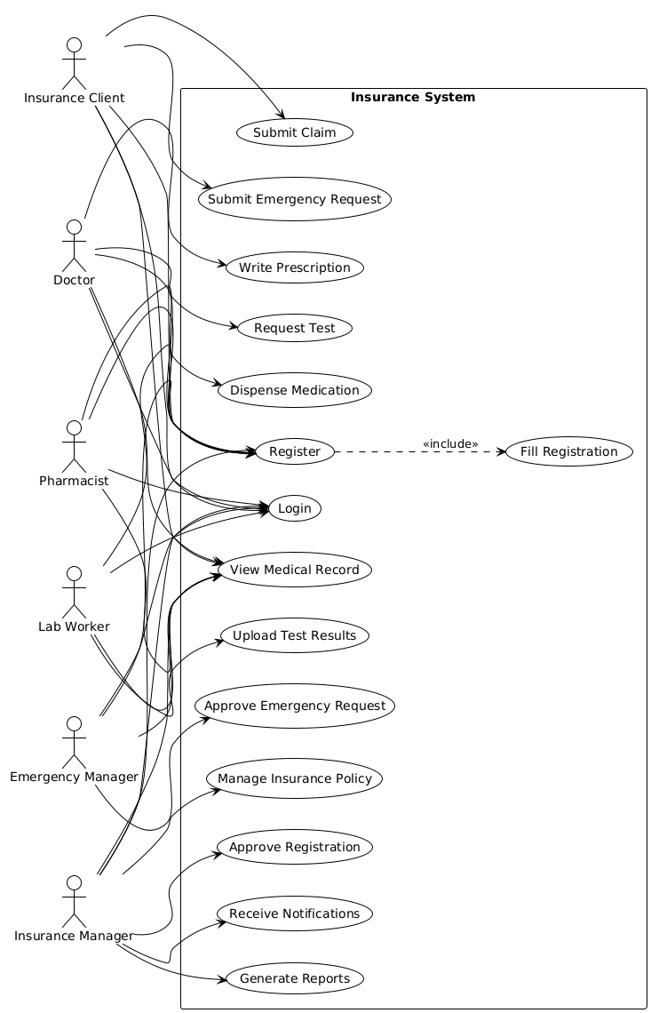

Figure 4 Use Case Diagram

System Modeling

This section presents a set of visual models to illustrate the structure and behavior of Birzeit University's health insurance system. The models include:
Class diagram: This illustrates the structure of the system, including entities such as users, healthcare providers, and insurance policies, along with their attributes and methods.
Sequence diagrams: This illustrates the interactions between system components over time, such as claims submission and processing.
Activity diagrams: This illustrates the workflows and processes within the system, such as claims submission and approval.
State diagrams: This illustrates the different states of entities (such as claims statuses) and how they transition based on events.
A component diagram : represents the physical and logical components of a system, showing how they interact and their dependencies. It focuses on the components that implement system functions.
A deployment diagram: depicts the physical deployment of software components on hardware nodes, illustrating the relationship between the software and the devices it runs on, including servers, appliances, and network architectures.

These models help visualize the system's functions and interactions, providing clarity for development and implementation.
    - Class Diagram

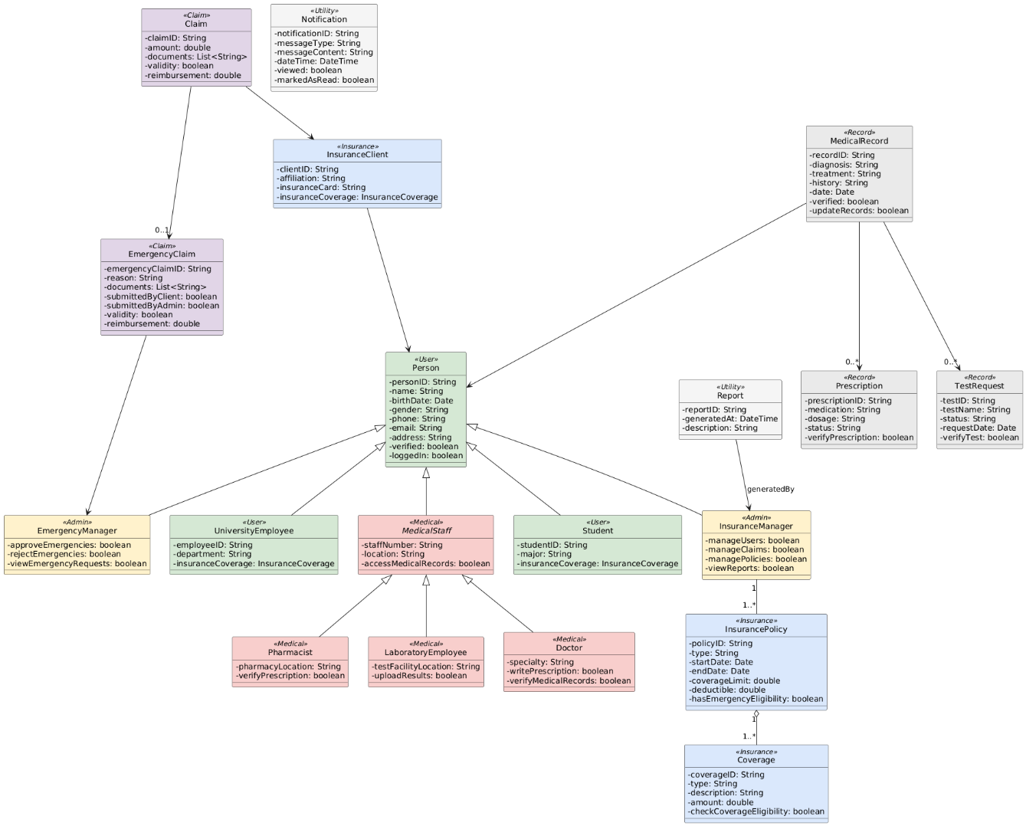

Figure 5 Class Diagram

Sequence Diagrams for Major Functionalities

User Registration Sequence Diagram:

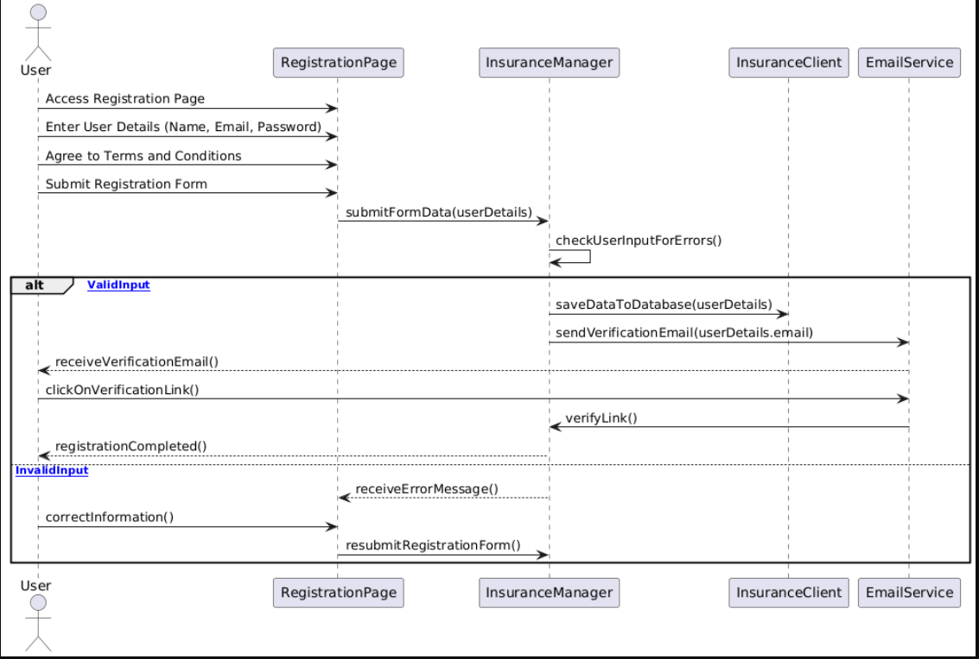
Figure 6: Registration Sequence Diagram

To create a sequence diagram for the Birzeit University Health Insurance System, the interaction between
Admin, System Frontend.

Step | Actor | Action
1 | User | Accesses the registration page through the Frontend (web or mobile app).
2 | User | Enters details (name, email, password) and agrees to the terms and conditions.
3 | User | Submits the registration form by clicking the "Submit" button on the RegistrationرPage.
4 | Frontend | Sends registration data (name, email, password) to the Backend (Relayer System) for validation.
5 | Backend | Validates input data (checks for correct email format, password strength, and duplicates).
6 | Backend | If valid, saves data (name, email, password) to the Database.
7 | Backend | Sends a verification email to the User to confirm their email address.
8 | User | Receives the verification email and clicks on the verification link.
9 | Backend | Verifies the link clicked by the User, confirming the email address.
10 | Backend | Updates user status as "Verified" in the Database after successful email verification.
11 | Frontend | Displays a confirmation message to the User ("Registration Complete! You can now log in.").

System Notification Sequence Diagram

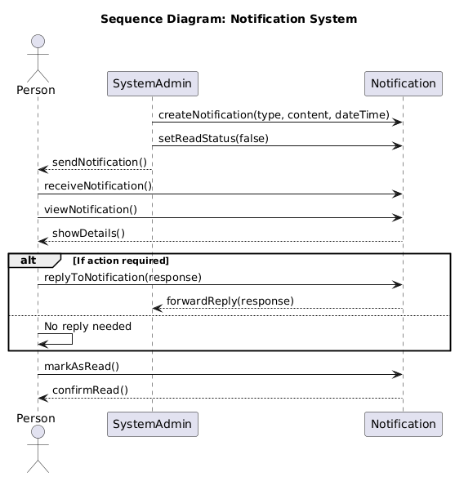
Figure 7: system Notification Sequence Diagram

EMRSQDIA Sequence Diagram

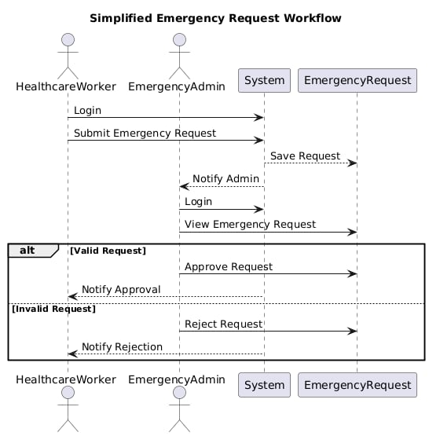
Figure 8: EMRSQDIA Sequence Diagram

Activity Diagrams

Activity Diagram User Registration

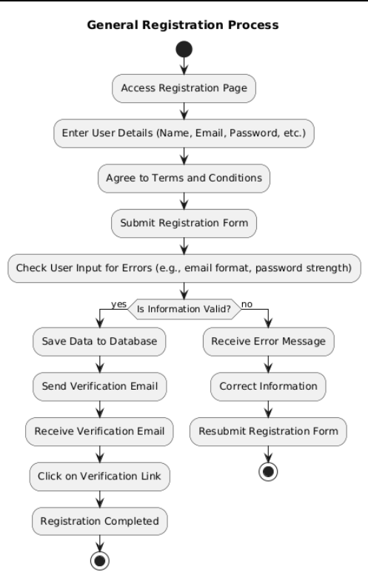
Figure 9: User Activity Diagram

System Notification Activity Diagram
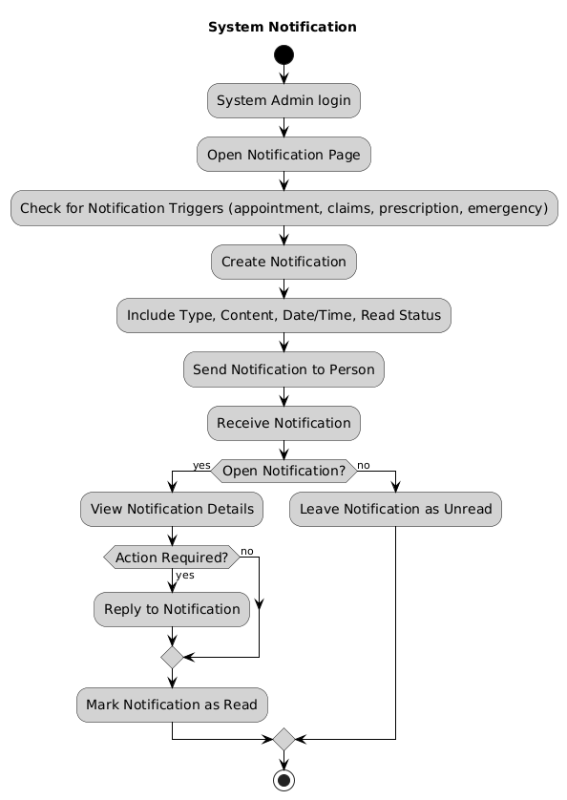

Figure 10: system notification Activity diagram

EMRACTDI Activity diagram

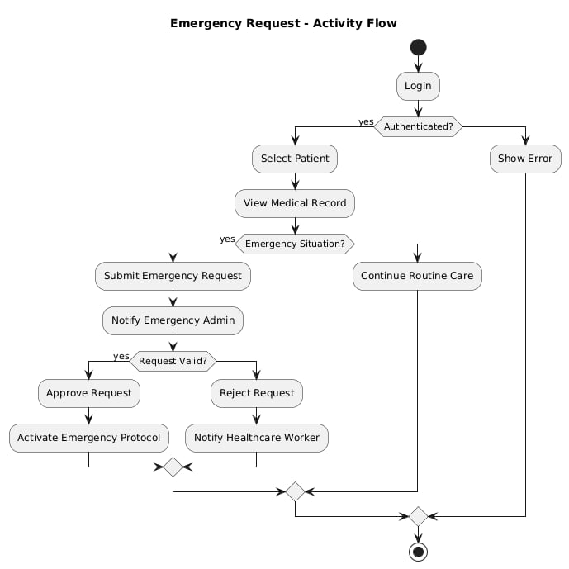
Figure 11: system notification Activity diagram

ERD Diagram

The ERD for an Insurance System shows the main entities like User, Manager, Claim, Policy, and Medical Provider and other. It illustrates how these entities are related, such as users submitting claims linked to specific policies and medical providers.

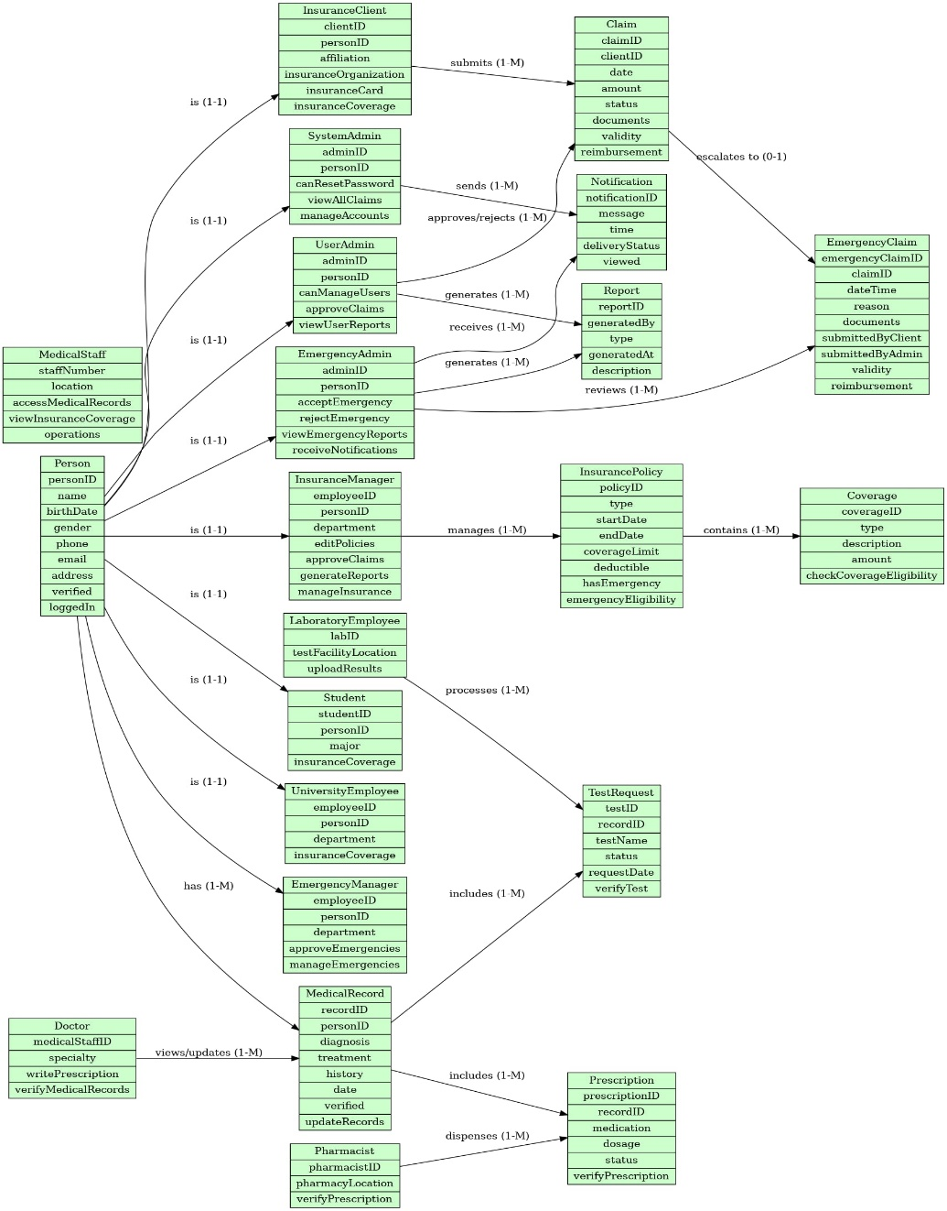

Figure 12: ERD Diagram

Sub-System

User Interface
An online interface accessible for students and staff to register, sign in, view insurance plans, submit claims, check the status of claims, and manage a personal profile.
2. Mobile Application
A mobile app available on multiple platforms providing the same information and services as the web interface, but designed for easy access from mobile devices.
3. Admin Dashboard
An admin system used to manage insurance plans, process claims, assign roles, and produce operational and financial audit reports.
4. Emergency Module
An emergency-based system used by emergency staff to see and accept or reject urgent insurance requests by users and medical staff.
5. Healthcare Provider Interface
A secure interface for doctors, pharmacists, and lab technicians to submit claims, manipulate

patient data, write prescriptions, and interact with test results.
6. Backend API (Spring Boot)
The core system and logic, handling requests and business logic and relaying between front-end interfaces and the database.
7. Authentication System (JWT)
Ensures secure access to the system with role-based login using JSON Web Tokens designed to restrict access to authorized users only and to keep sensitive data secure.
8. Insurance Plan Manager
A component that is tasked with creating and defining insurance plans, specifying eligibility, and adding plans or assigning plans to users based on their role.
9. Claims Processor A claims processor is responsible for the complete validation and

decision making process for submitted claims by automating approval and denial to unitize processing time.

10. Medical Record Manager
Manages the accessing and updating of users medical records, permitting password-protected providers to enter diagnoses, treatment history, etc.
11. Prescription Manager
Allows doctors to create and update prescriptions, and checks for prescription validity prior pharmacy dispensing and insurance coverage.
12. Appointment Manager
Facilitates users' appointment scheduling, re-scheduling and cancellation of medical doctor appointments, while allowing medical staff to manage their own calendars.
13. Emergency Request Manager
Handles emergency medical request processing securely with the use of priority handling, where administrators can push new requests to the front of the queue for quick review and approval, escalation etc.
14. Notification System
Provides in-box or email notifications about claim information based events, scheduled appointments, prescription status, or alerts for changes in work (system) regulation.
15. Reporting Engine
Provides a statistical data reporting, operational reporting, and financial report generating engine for these if needed by administrative personnel to monitor activity and assist with decision making.
16. Auto-Rejection Engine
Provides a rejection engine based on similarity checks of new reports against previously rejected reports to reject fraudulent claims and better administrated workflow.
17. PostgreSQL relational database
Provides a relational database for the collection of all system information including user accounts for medical history, insurance plans for creditability, and claim information.
18. Mail Server
Provides email services for sending account verification emails, notification services, and system email messages to users and administrators.
19. Map & Location Service
Provides users with the ability to find nearby service locations and use built-in mapping to obtain directions, etc.

System environments

The Birzeit University Health Insurance System operates using a combination of web and mobile technologies to ensure a seamless, efficient, and secure platform for managing health insurance services:

Client-Side

For our system’s web applications, we use React to develop three main interfaces:
      - Administration Portal - Allows administrators to create and manage health insurance policies, track claims, define eligibility criteria (e.g faculty, and staff), and monitor the overall status of claims and policy enrollment processes. Administrators can also manage healthcare provider details and maintain data integrity.
      - Emergency Administration Portal – allows emergency administrators to view, accept, or reject emergency claims submitted by the medical staff.
      - User Portal - Allows students, faculty, and staff to register, log in, view available health insurance plans, submit claims, track claim status, and access their medical records. The portal is designed to be user-friendly, ensuring all users can easily manage their insurance needs and stay up-to-date on their coverage.
      - Healthcare Provider Portal - Enables authorized healthcare providers to securely access medical records, verify patient coverage, submit claims for medical services, and interact with the system to receive real-time updates. This portal facilitates secure communication between healthcare providers and the insurance system.
Additionally, we have a React Native mobile app specifically designed for users who prefer mobile access. This application offers the same features as web portals, such as registration, viewing insurance details, submitting claims, and tracking their status, ensuring a consistent and convenient experience across both mobile and web platforms.
This approach ensures easy access, security, and efficiency to Birzeit University's health insurance system, providing all users with the tools they need to easily manage their insurance services across multiple platforms.

Back-End

For Birzeit University's health insurance system, we use Spring Boot (Java) for server logic and RESTful APIs. The backend connects to a PostgreSQL database, which securely stores user information, policy details, claims data, and other relevant records. The backend architecture is designed to efficiently handle real-time policy status updates, claims processing, and user interactions.

For security, we use Spring Security with JWT (JSON Web Tokens) for user authentication and authorization. This system supports various roles, including "User," "Administrator," "Healthcare Provider," and "Claims Processor," ensuring that only authorized individuals can access specific system features and modify relevant data.

To facilitate the management of entities and their Data Transfer Objects (DTOs), we use Map Struct, which provides automatic mapping between entity objects and DTOs, ensuring our code remains clean, maintainable, and efficient.

Additionally, we ensure data integrity and secure communication between the system's front-end and back-end interfaces through secure APIs. The back-end is designed to be scalable and flexible, allowing for easy integration with external healthcare systems or future technologies.

This approach enables Birzeit University's health insurance system to provide a secure, reliable, and efficient platform that simplifies the management of health insurance services for the university community.

Dependencies and Libraries Include:

- Spring Boot Starter Web, Data JPA, and Security: To build RESTful APIs, manage database operations, and implement role-based access control (administrator, user, healthcare provider, claims processor).

- PostgreSQL JDBC Driver: To connect to a PostgreSQL database to securely store user data, insurance documents, claims, and medical records.

- Spring Boot Starter Mail and Validation: To send emails, such as verification codes for user registration, and handle input validation to ensure data integrity.

- Lombok and MapStruct (with Lombok MapStruct binding): To reduce boilerplate code in the application and simplify conversion between entities and DTOs, making the codebase more maintainable and easier to read.

System Architecture

This section provides an overview of the high-level design of Birzeit University's health insurance system, explaining how the various components (such as web interfaces, mobile application, back-end services, and data storage) interact to deliver a seamless and secure experience for users, healthcare providers, and insurance administrators.

Software Architecture
The architecture of the Birzeit University Health Insurance System ensures secure, efficient, and scalable operations across its components, including the backend, database, and user interfaces. Here's a breakdown of the architecture:
- User Interfaces:
  - Web Portal for Faculty, Staff, and Healthcare Providers (Frontend).
  - Mobile App built with React Native, providing access for both faculty, staff, and healthcare providers.
- Backend System:
  - Spring Boot (Java) for processing insurance claims, managing policies, and handling business logic.
  - RESTful APIs to interact with the database and frontend applications.
- Database:
  - PostgreSQL Database to store all user data, claims, medical records, and insurance policies.
- External Services Integration:
  - Integration with third-party services like healthcare providers, medical record services, and pharmacies to verify claims and manage prescriptions.
- Security & Compliance:
  - JWT (JSON Web Tokens) for user authentication and role-based access control.
  - Spring Security for protecting the application and user data.

- Notifications:
  - Email Server to send notifications for account verification, claim updates, and appointment reminders.

High-Level Architecture

The system is deployed using a React Web/Mobile frontend, a Spring Boot backend, a PostgreSQL database, and AWS Cloud services (EC2, RDS, S3, Lambda), communicating securely via REST APIs and SDKs for scalable cloud integration.

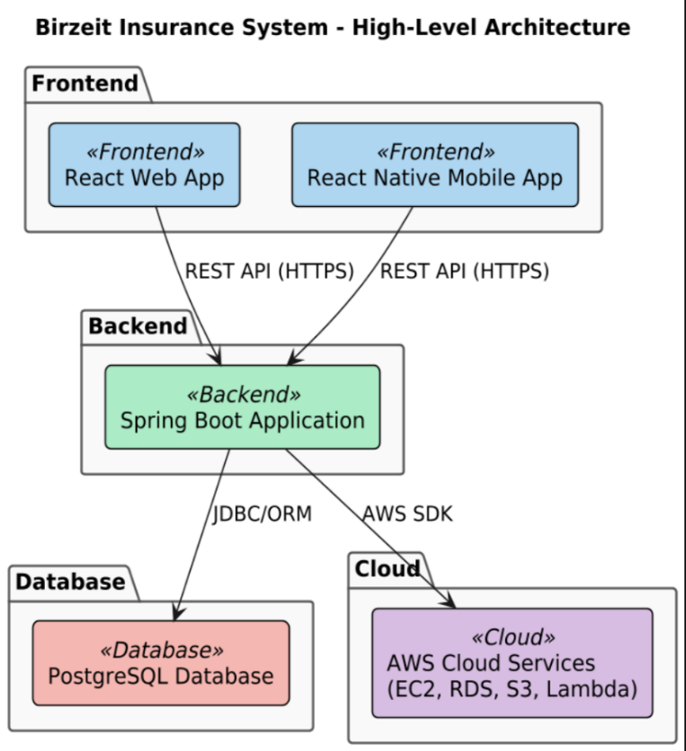
Figure 13 High-Level Architecture

System Deployment Diagram

This diagram illustrates how system components are deployed across servers and

devices, including front-end clients (web/mobile), back-end services on application servers, and a central database server. This ensures secure distributed,

and efficient system operation.
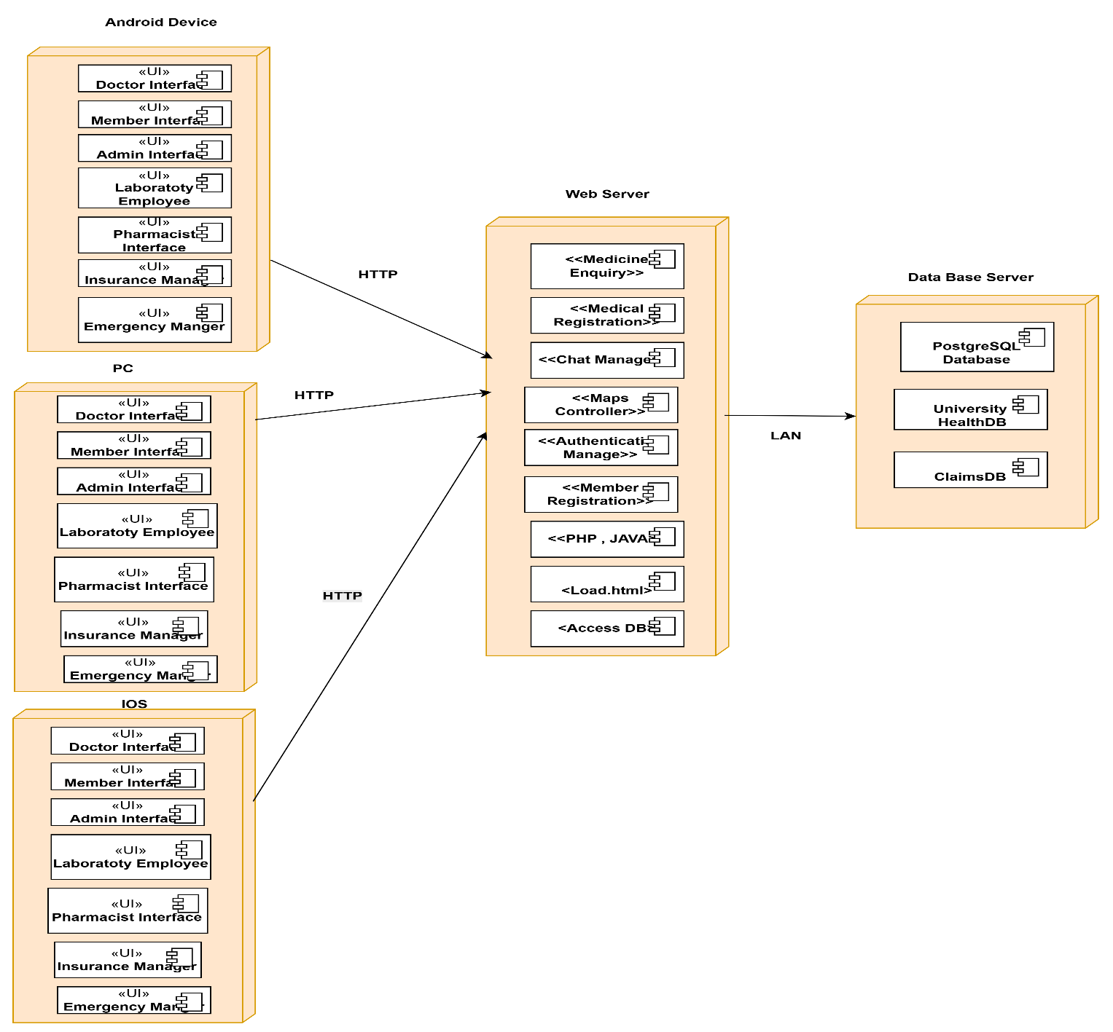

Figure 14 Deployment Diagram

System Component Diagram

This system component diagram illustrates a three-tiered architecture:

Application Layer:

Interfaces (portals) for users, such as members, physicians, pharmacists, healthcare staff, lab technicians, and insurance administrators, to interact with the system.

Business Logic Layer:

Manages core functions, such as user and customer management, medical record processing, emergency requests, and insurance operations. Each user interface component connects to its corresponding business service for processing.

Data Access Layer:

Provides secure storage and retrieval of data through a central database. It also enforces access control, encryption, authorization, secure processing, and messaging, ensuring data integrity and security.

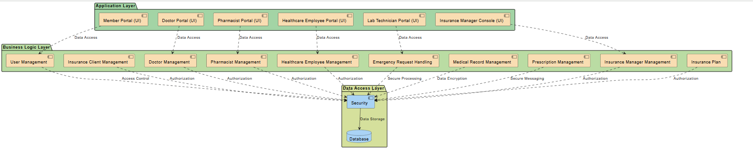

Figure 15 Component Diagram

GUI Design

1. User Registration Interface (Web and Mobile):

A web interface that enables users to register by submitting a form to create an account. The form typically includes fields for personal information, such as name, email address, and password. After submitting, the system sends a registration request for review or verification before activating the account. This process ensures secure registration and a smooth user experience.

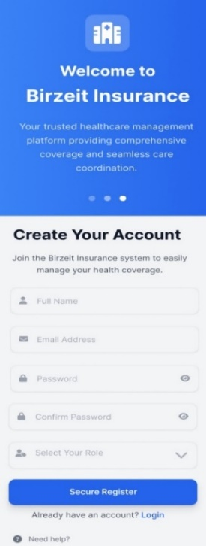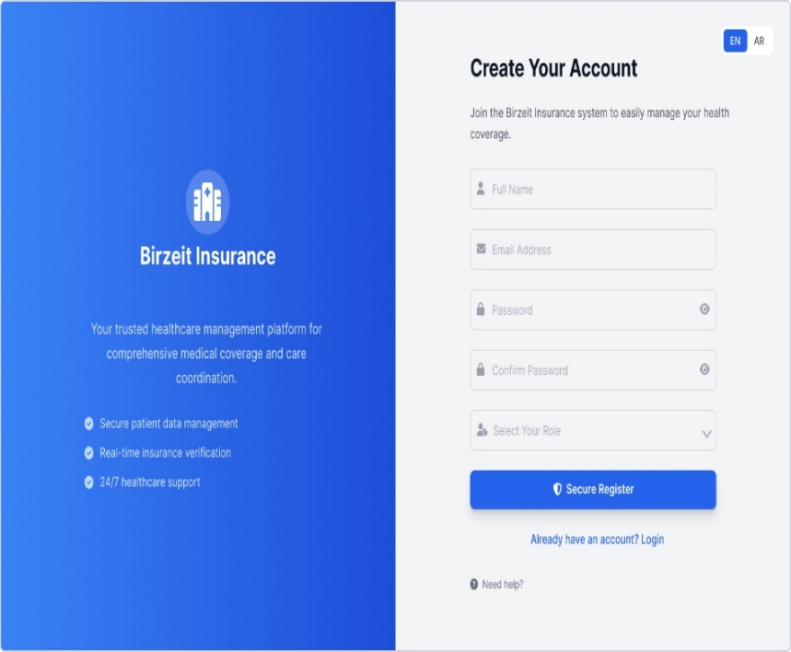
Figure 16 : Registration Web & Mobile

2. User Login Interface (Web and Mobile):

The user login interface is designed to provide quick and secure access for existing users. Whether on the website or the app, users can easily enter their credentials, with additional options such as "Remember Me" and "Forgot Password" to ensure convenience and security during the login process.

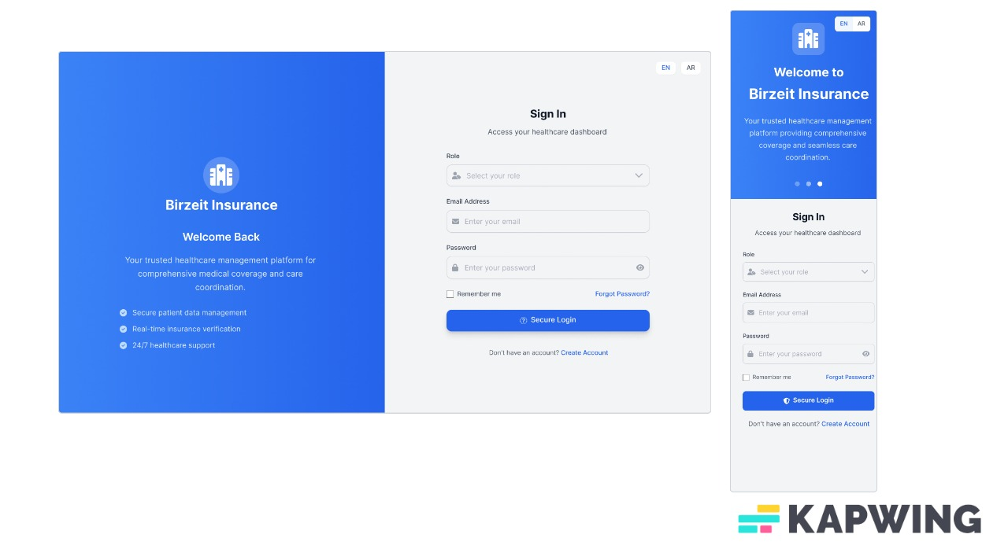

Figure 17 Sign in web & mobile

3 . Member Dashboard Interface (Web and Mobile):

The Member Dashboard interface is designed to provide a personalized and user-friendly experience. Whether accessed via the web or mobile app, the dashboard provides members with an overview of their account details, active insurance policies, claims history. The interface includes quick access to key sections such as View Profile, Submit Claims, Policy Details. All content is clearly presented and easy to navigate, ensuring members can easily manage their health insurance needs.

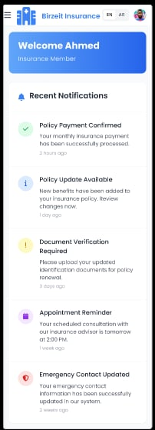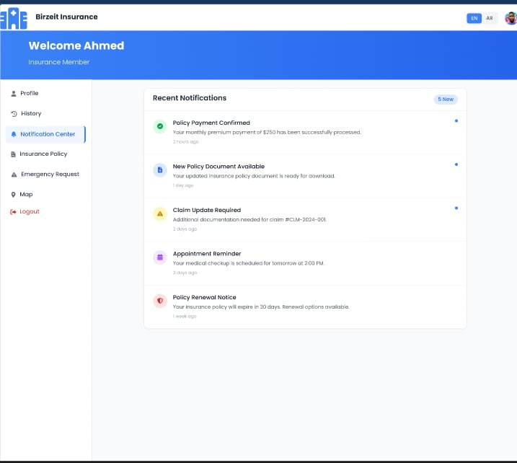

Figure 18 Member Web & mobile

Doctor Dashboard (Web and Mobile):

The physician interface is designed to enable healthcare professionals to efficiently access and manage patient information, whether via the web or mobile app. The interface provides secure access to patient medical records, claims statuses, and policy details. Physicians can quickly view and update medical reports, upload prescriptions, and approve or decline claims for their services. The interface also offers features for scheduling appointments, managing consultations, and communicating securely with patients. Its user-friendly design ensures that physicians perform these tasks seamlessly while maintaining the highest standards of confidentiality and data security.

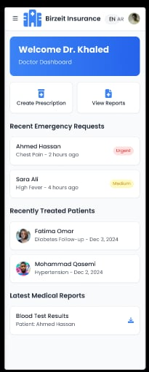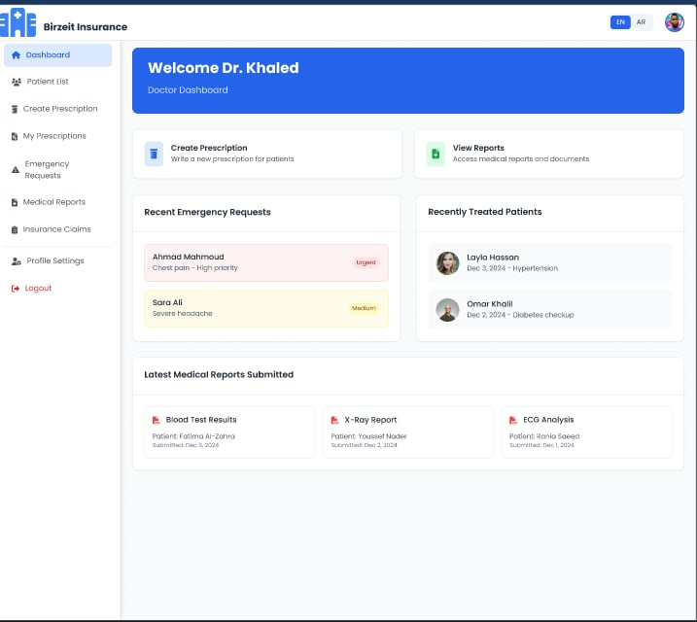

Figure 19 : Doctor Web & mobile

Doctor Registration (Web and Mobile):

The physician registration interface is designed to enable medical professionals to create and manage their profiles on the health insurance platform. This interface allows physicians to enter their personal and professional data, including name, qualifications, specialty, experience, and contact information. It often includes verification steps to ensure the accuracy of the information entered. This design aims to ensure physicians can easily register and update their information while maintaining a secure and reliable system.

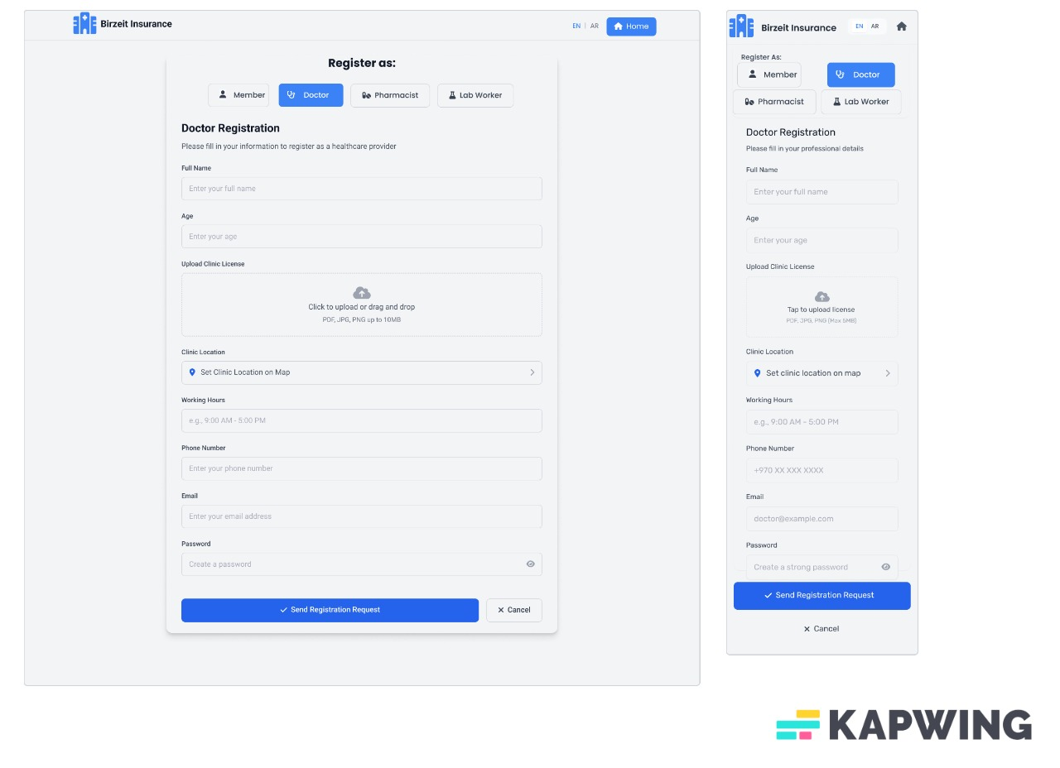

Figure 20 Doctor Registration Web & mobile

Doctor Report (Web):

The physician reports interface is designed to enable physicians to create, view, and manage

reports for their patients. This interface typically includes fields for entering patient information, diagnoses, treatment plans, prescriptions, and other medical details. Physicians can also upload test results, scans, or other relevant documents. The design prioritizes clarity and ease of use, ensuring physicians can quickly access and update patient information. The report can be shared digitally with patients or other physicians as needed.

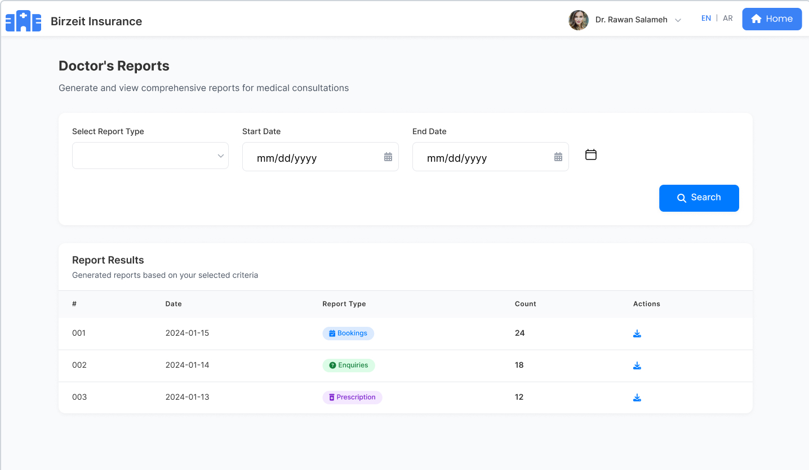
Figure 21 Doctor Report 1

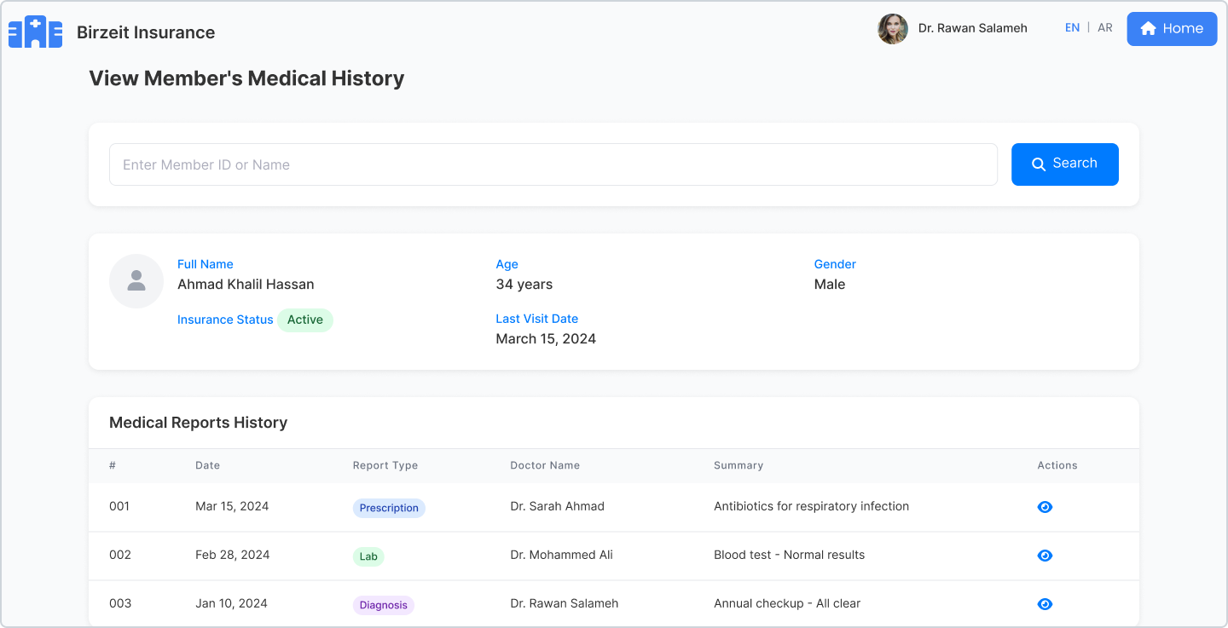
Figure 22 Doctor Report 2

Pharamtics Registration (Web):

A web interface enables pharmacists to register and manage their professional profiles, including their personal data, qualifications, and credentials. This interface ensures that information is securely transmitted and verified for access to the platform's services.

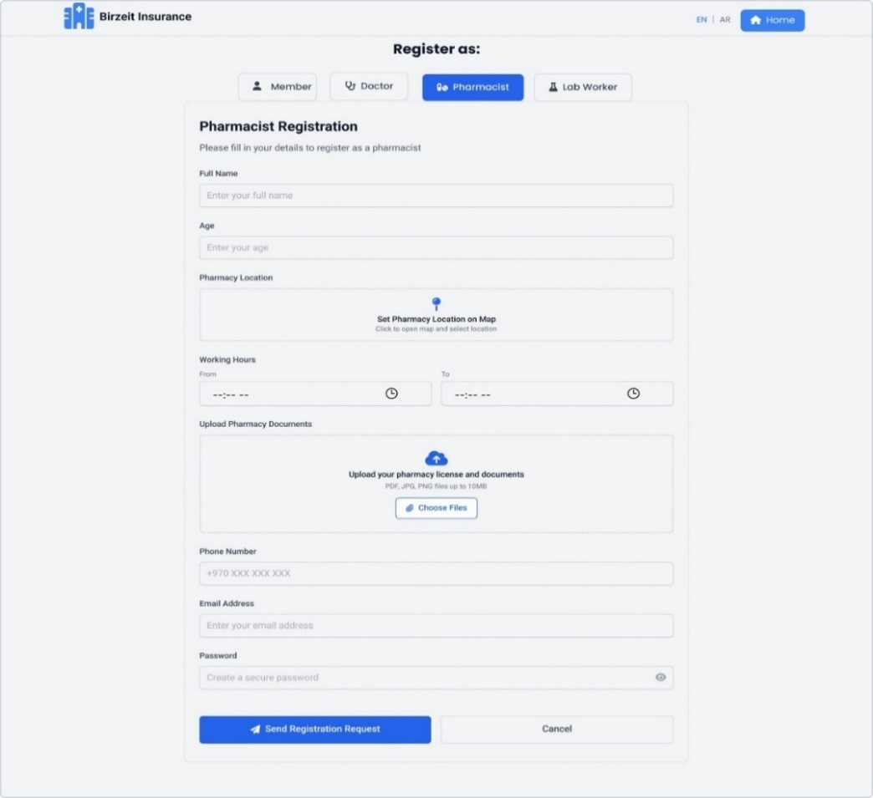

Figure 23 Pharmacist Registration

Lab Worker Registration (Web):
A web interface for laboratory workers to register and manage their profiles, including personal details, qualifications, and certifications, with secure data entry and verification.

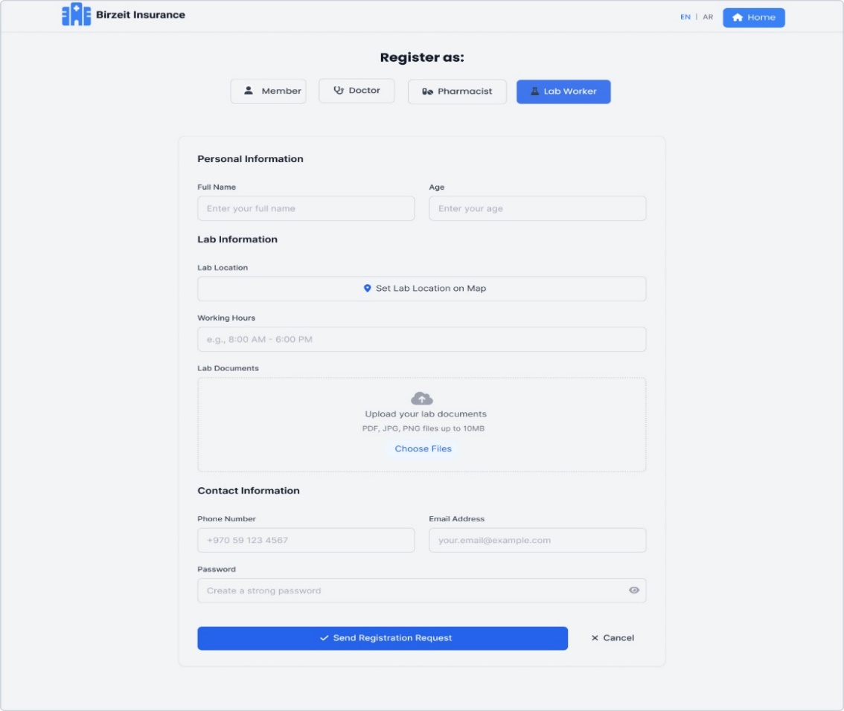
Figure 24 Lab Worker Registration

Pharamtics Enquiry (Web):
A web interface designed to enable users to inquire about pharmacy-related services, such as medication availability, prescription details, and pharmacy locations. It typically includes a search feature, inquiry fields, and contact options for further assistance. The design ensures users can easily access relevant information and communicate with pharmacy professionals, providing a seamless and informative user experience.

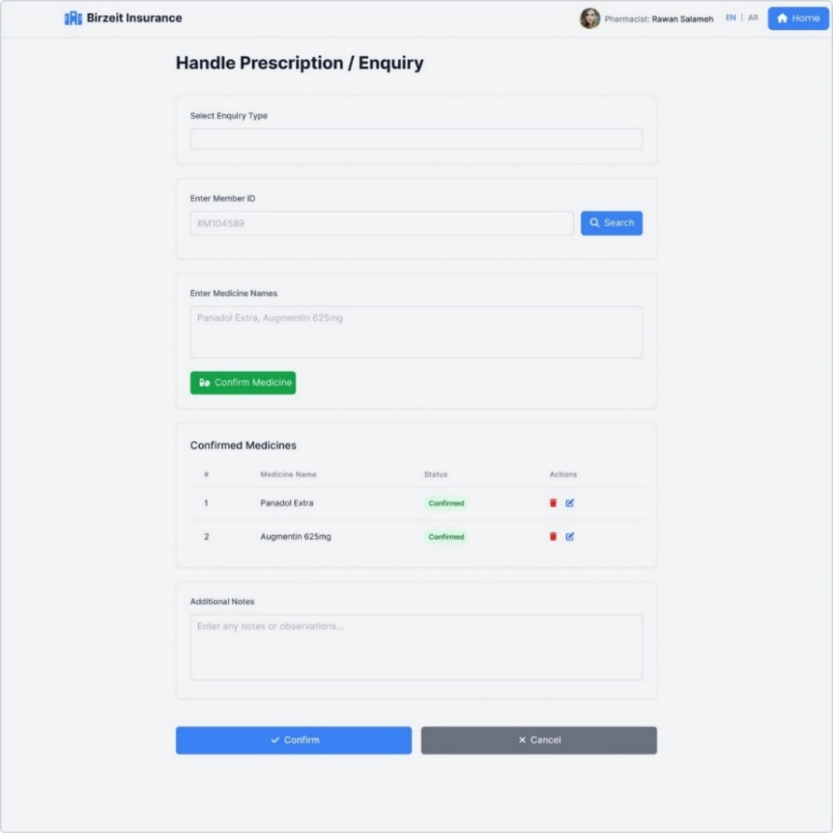
Figure 25 Pharmacist Enquiry

Lab Worker Enquiry (Web):

This web feature allows lab workers to view and respond to enquiries related to lab test requests,

patient results, or insurance approvals. It helps streamline communication between the lab, patients,

and insurance providers.

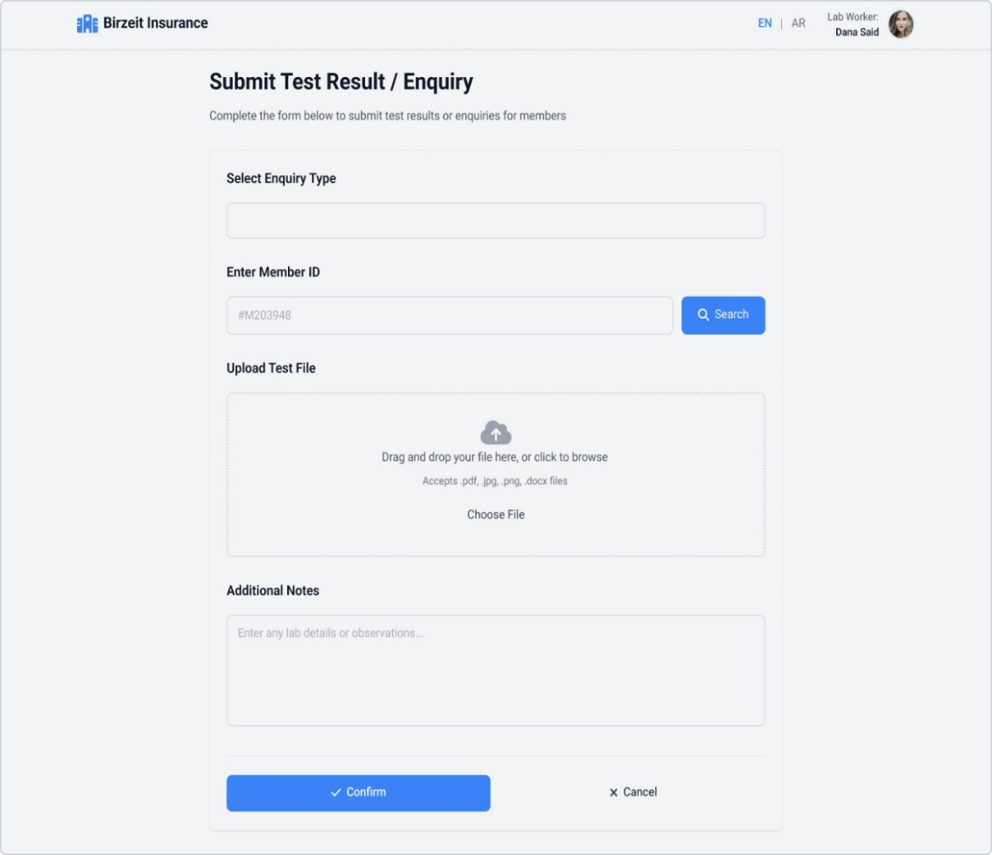
Figure 26 Lab Worker Enquiry

Doctor Enquiry (Web):

A web interface for users to search and inquire about doctor BLED on Specialty, Location, and Availability, Providing Easy Access to Doctor Profiles and Appointment Information.

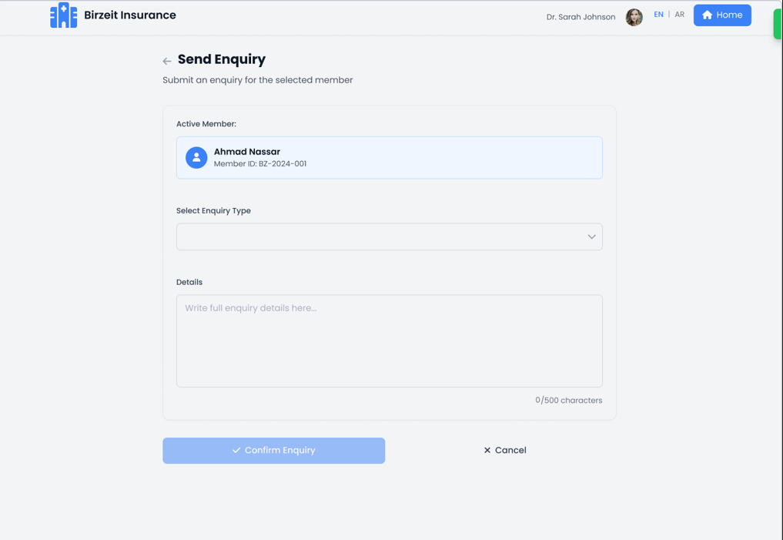
Figure 27 Doctor Enquiry

Emergency report (Web):

An interface for quickly documenting and managing emergency situations, including patient details, symptoms, and treatment actions, with the ability to generate and share reports for medical teams.

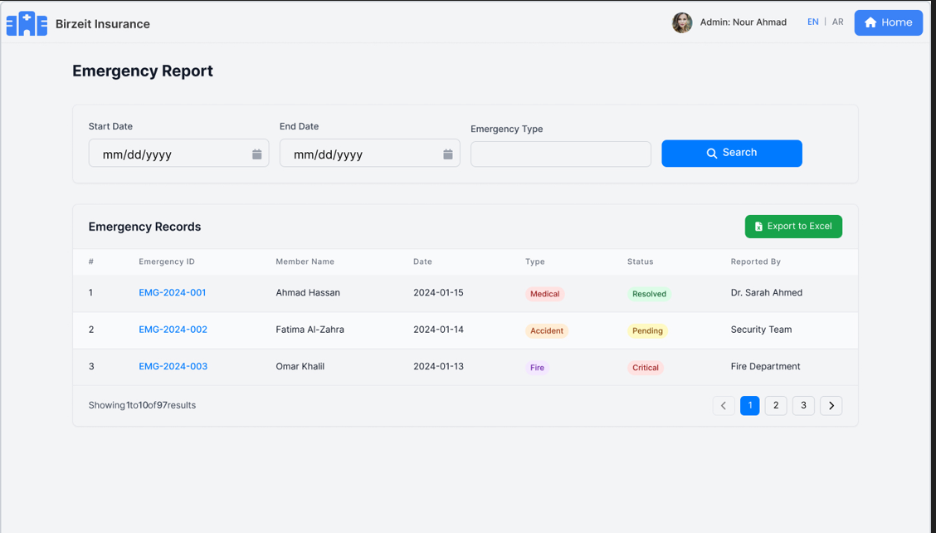
Figure 28 emergency report

System Admin Report 1 Medical Worker Report :

This report provides the system admin with an overview of medical workers' activities related to insurance claims, approvals, and patient services. It ensures transparency and helps monitor their compliance with insurance policies and procedures.

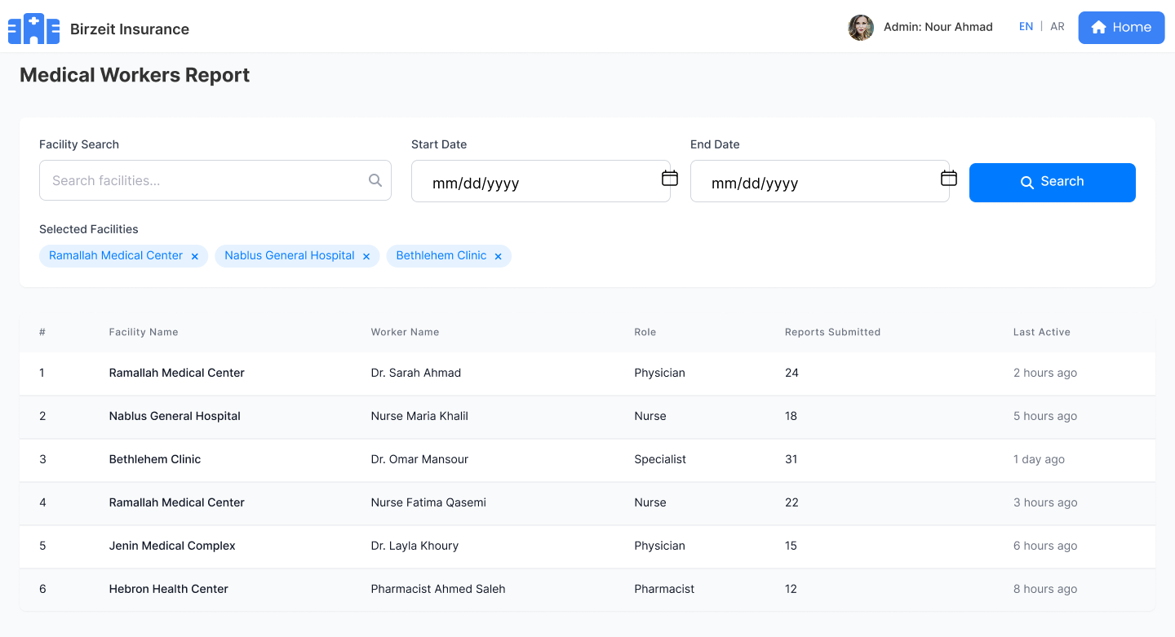
Figure 29 medical worker report

System Admin Report 2 Member :

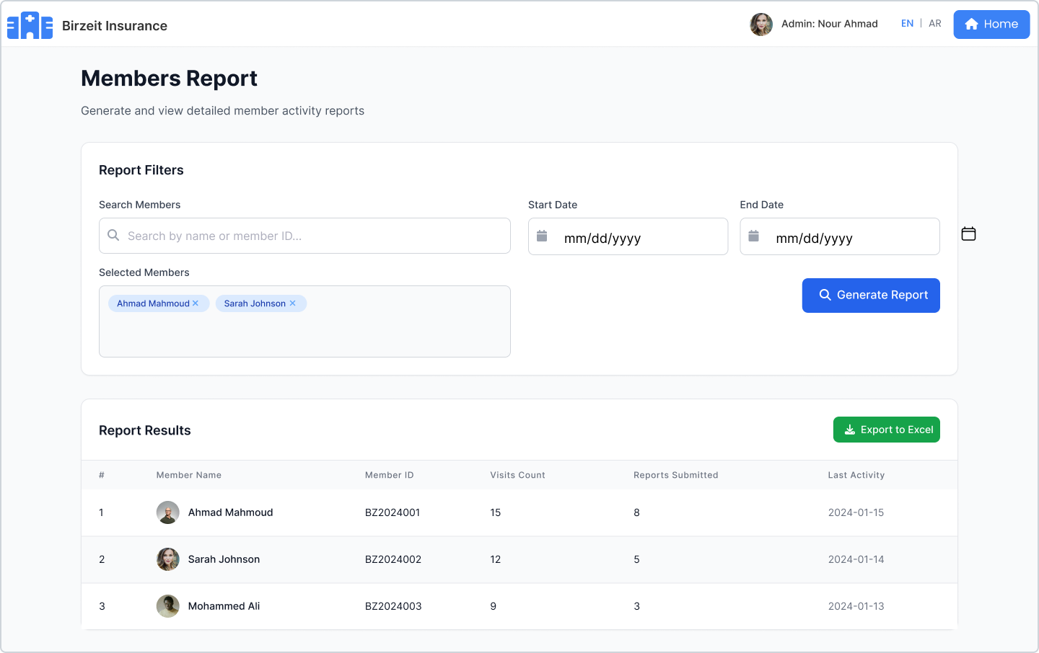
Figure 30 member report

Chapter 4: Conclusion and Future works:

Review of the project

Birzeit University's health insurance system is a comprehensive solution that leverages modern web and mobile technologies to streamline communication, claims processing, and document management. Using frameworks such as React Native, Spring Boot, and PostgreSQL, along with secure backend technologies, the system ensures data security, reliability, and scalability. The relay system simplifies the process by abstracting away complex blockchain interactions, allowing users to interact with the system seamlessly without the need to directly manage cryptocurrencies or blockchain technologies.

Key features, such as user registration, profile management, claims submission, and real-time claims status tracking, ensure the system provides a user-friendly experience. Integration with healthcare providers enables efficient claims validation, while the backend handles the core business logic for document management and processing.

The mobile app provides easy access to users, ensuring faculty and staff can manage their insurance needs wherever they are. The system also includes robust security mechanisms, such as JWT authentication and role-based access control, to protect sensitive data and ensure only authorized users can access or modify information.

This project lays a solid foundation for efficient, transparent, and secure health insurance management, addressing current shortcomings in traditional systems. It also provides valuable insights into the potential of technology to improve administrative processes and enhance service delivery for students, faculty, and staff. Future improvements may include expanding the system to incorporate additional healthcare services and enhancing automation to further streamline processes.

Future works

Integration with Healthcare Systems:
Integrating Birzeit University's health insurance system with existing healthcare management systems, such as Ritaj (for student data), will facilitate data synchronization, policy management, and eligibility verification. Students will be able to use their university data to seamlessly access the health insurance system, reducing entry barriers and ensuring data consistency across platforms. This integration will also enable the system to automatically retrieve and verify details such as student status, department, and enrollment information, ensuring only eligible users interact with insurance features. Furthermore, election events and notifications regarding policy updates or healthcare-related events can be synced with university calendar systems to improve engagement.
Improved User Interface and User Experience:
The next phase of the system will focus on improving the user interface (UI) and user experience (UX). The system will prioritize simplicity and intuitive design, allowing users of all technical skill levels to navigate and interact with the platform with ease. This includes designing responsive designs that seamlessly adapt to various devices, including desktops, tablets, and mobile phones, ensuring users can easily access the system, whether at home, at work, or on the go.
Enhanced Security Protocols:
To enhance user data protection and system integrity, advanced security features will be introduced. Biometric authentication (such as Face ID) will be enabled for mobile users, providing a more secure and efficient way to log in. Additionally, two-factor authentication (2FA) will be implemented for internet users, including methods such as SMS codes or email verification. This will ensure secure access and protect users from unauthorized access. Blockchain technology will continue to play a crucial role in ensuring the stability and integrity of security data and transactions, making the system resistant to tampering and fraud.

Multilingual Support:
To ensure accessibility and inclusiveness, multilingual support will be introduced to meet the needs of a diverse user base. Users will be able to select their preferred language during registration or via settings. All system interfaces, notifications, and help content will be available in multiple languages, enhancing the user experience and making the platform more accessible to speakers of different languages. As user needs evolve, dynamic translation services will ensure that language support is updated and keeps pace with the growing user base.

Advanced Analytics and Reporting:
In the future, advanced analytics and reporting tools will be integrated into the system to provide valuable insights for both administrators and users. Real-time dashboards will allow management to track key metrics, such as insurance claims status, user engagement, and participation rates. For healthcare providers and insurance managers, the system will provide tools to monitor claims efficiency, user activity, and other relevant data. Additionally, candidates and insurance managers will benefit from campaign performance analytics, which tracks user interactions, such as likes, comments, and overall engagement with policy-related posts. This will help them understand user preferences and improve their outreach.ctions.

Final Summary and Development Roadmap

This report presents the analysis, design, and partial implementation of the Birzeit University Health Insurance System, a comprehensive digital platform that aims to simplify and modernize the management of health insurance services for the university community. During this semester, we explored the technical foundations of the project, identified the system's main objectives, and defined its functional and non-functional requirements. A comprehensive system analysis was conducted, including use case modeling, class diagrams, sequence and activity diagrams, customer relationship diagrams (ERDs), and subsystem components. The infrastructure and technological environment were also detailed, with a focus on using React Native for front-end development, Spring Boot for back-end services, and PostgreSQL for data storage, all secured via JWT authentication.

By documenting the system environment, technical options, and data flow, the team laid a solid

foundation for actual implementation. Furthermore, the report addressed current challenges in traditional

and Web 2.0-based insurance platforms and demonstrated how our system aims to overcome them using a modern, scalable, and secure architecture.

Next Semester Plan:

Complete and implement all modules, including the user portal, administration dashboard, and

healthcare provider interface on both web and mobile platforms.

Build and test a RESTful API layer to connect the React Native front-end to the Spring Boot back-end.

Integrate real-time claims tracking, emergency services, and appointment and prescription notifications.

Conduct unit and integration tests across system modules.

Prepare for User Acceptance Testing (UAT) using real test data from the university.

Deploy the system in a controlled environment and collect feedback for improvements.

The project is on track to deliver a fully featured, secure, and user-friendly health insurance system, tailored to the needs of Birzeit University. The next semester will focus on implementing, testing, deploying, and documenting the final product.

References

[1] | s. Musib, Spring Boot in Practice, Norwell : USA: Manning Publications, 2022.
[2] | Online. [Online]. Available: https://www.youtube.com/watch?v=QYDHxlpr04U..
[3] | M. Schwarzmüller, React Key Concepts, Birmingham: Packt Publishing Ltd, 2022.
[4] | B. Eisenman, "Learning React Native," in React Native,, California, O'Reilly Media, Inc., October 2017.
[5] | J. C. W. a. J. D. Drake, Practical PostgreSQL, Sebastopol, California,: O'Reilly & Associates,, 2002.
[6] | M. W. a. A. Wittig, Amazon Web Services in Action, NewYork: Manning Publications Co, 2023.
[7] | QAified, "How to Use Postman for API Testing," QAified, 9 8 2023. [Online]. Available: https://qalified.com/blog/postman-for-api-testing/..
[8] | S. Ajibola, "How to Use Git and GitHub – Introduction for Beginners," freeCodeCamp, 2022. [Online]. Available: https://www.freecodecamp.org/news/introduction-to-git-and-github/..
[9] | F. Stiano, "Designing and Prototyping Interfaces with Figma,," Birmingham,, Packt Publishing Ltd, 2022.
[10] | H. Z. Y. &. W. L. Chen, "Digital transformation of health insurance systems in the Web 2.0 era," ealth Informatics Journal,, p. 2524–2537., 2020.
[11] | S. D. P. S. T. C. S. &. A. H. Singhal, "For better healthcare claims management, think “digital first”," McKinsey & Company., 2019.
[12] | KFF, "Navigating the maze of health insurance coverage. Kaiser Family Foundation," 2023. [Online]. Available: https://www.kff.org/private-insurance/issue-brief/navigating-the-maze-a-look-at-health-insurance-complexities-and-consumer-protections/.
[13] | J. &. E. R. Smith, "Paper-based medical systems: A barrier to timely healthcare delivery," Global Health Review,, p. 25–31., 2018.
[14] | M. e. a. Burhan, "eHealth Cloud Security Challenges," Challenges: A Survey." Journal of Medical Systems, p. 142, 2019.
[15] | B. Eisenman, Learning React Native, California: 2017, O'Reilly Media,.
[16] | J. T. G. &. S. Chouhan, "Efficient Backend Development with Spring Boot," International Research Journal of Modernization in Engineering Technology and Science, p. 10828–10829., 2025.
[17] | P. G. D. Group, "The world’s most advanced open source object-relational database system.," 2025. [Online]. Available: https://www.postgresql.org/about/.
[18] | Cigna., "myCigna Mobile App Features.," 2023. [Online]. Available: https://www.cigna.com.
[19] | S. M. o. Health., "Sehaty App Overview," 2023. [Online]. Available: https://www.sehaty.sa.
[20] | D. B.H., "BeneCare Health Insurance," 2025. [Online]. Available: https://www.benecare.com/.
[21] | Carefirst, Carefirst Health Insurance, [Online]. Available: https://www.carefirst.com.
[22] | M.Schlosser, 2012. [Online]. Available: https://www.youtube.com/watch?v=QYDHxlpr04U.
[23] | Ramachandrappa, A Comparative Analysis of Native vs React Native Mobile App Development., p. 57–62., 2024.

Abbreviations

Abbreviation | Meaning
EHR | Electronic Health Records
HIPAA | Health Insurance Portability and Accountability Act
AI | Artificial Intelligence
IoT | Internet of Things
HL7 | Health Level 7
EMR | Electronic Medical Records
API | Application Programming Interface
FHIR | Fast Healthcare Interoperability Resources
Rx | Prescription
PCP | Primary Care Physician
TPA | Third-Party Administrator
COB | Coordination of Benefits
PPO | Preferred Provider Organization
HMO | Health Maintenance Organization
SSO | Single Sign-On
EDI | Electronic Data Interchange
SQL | Structured query language
ML | Machine Learning
JSON | JavaScript Object Notation
AWS | Amazon Web Services

7 Turnitin

